CIS016-1 Assignment 3 Hotel Booking System Group Report

Contents

1. Introduction 2

2. System Design 2

2.1. UML Use Case Diagram 2

2.2. UML Class Diagram 2

2.3. Database Design 4

3. Implementation 5

4. Testing 8

5. Reflection and Responsibilities 16

6. Conclusion 17

7. Appendix 18

# Introduction

The task of this group project was to investigate the brief provided for the Hotel Booking System scenario, and implement a system that includes all the required specifications of the brief. The specifications of the Hotel Booking System are as follows: The system needs a database to be created to store customer data (name, address, email, and telephone number), booking information (start and end date, double or single room), and room information. Customers need to be able to register using such as their email address, password, address, phone number, and credit card information. A registered customer needs to be able to book a room by providing their first and last name, check-in and check-out dates, and if a double or single room is required. Customers should also be able to view their bookings, and change or cancel them. The system needs to be able to check if the requested room is available. Hotel managers must sign in before anything can be done, and should be able to assign a room to each booking, view existing bookings, as well as also being able to create, update, and cancel bookings.

# System Design

## UML Use Case Diagram

Below is the Use Case Diagram that was provided for us in the assignment brief. The diagram shows that there needs to be two users that interact with this system, a Customer and a Hotel Manager. It then shows the use cases within the system, and the processes that need to be present within the system. After studying this diagram, we understood the requirements of the system that we needed to create, and how the system should work. This in turn allowed us to create a system that met these requirements, and successfully meet the purpose of the task.

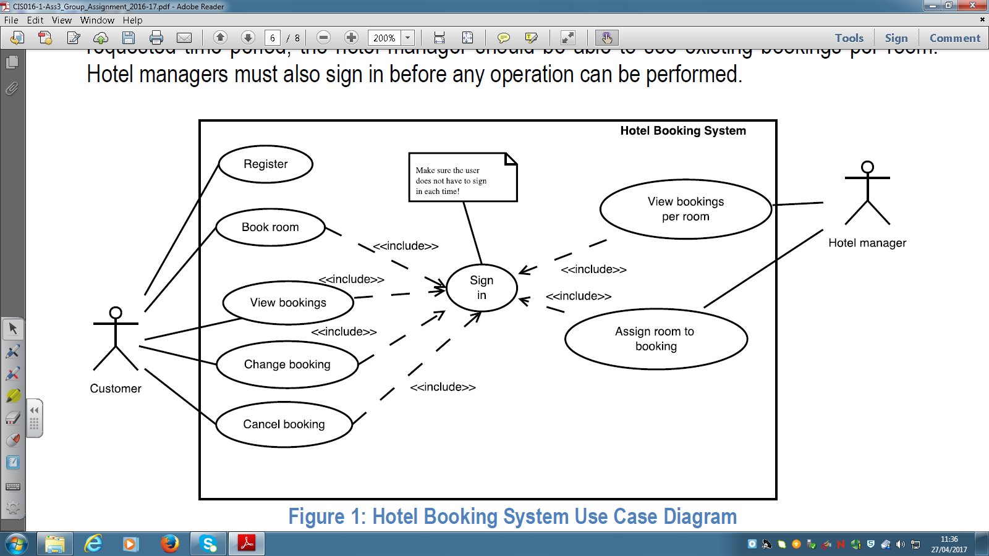

Figure 1: Hotel Booking System Use Case Diagram

## UML Class Diagram

Below is our class diagram that we created for our system. This diagram shows the four classes of our system, SignIn, Sign Up, MainMenuCustomer, and MainMenu.

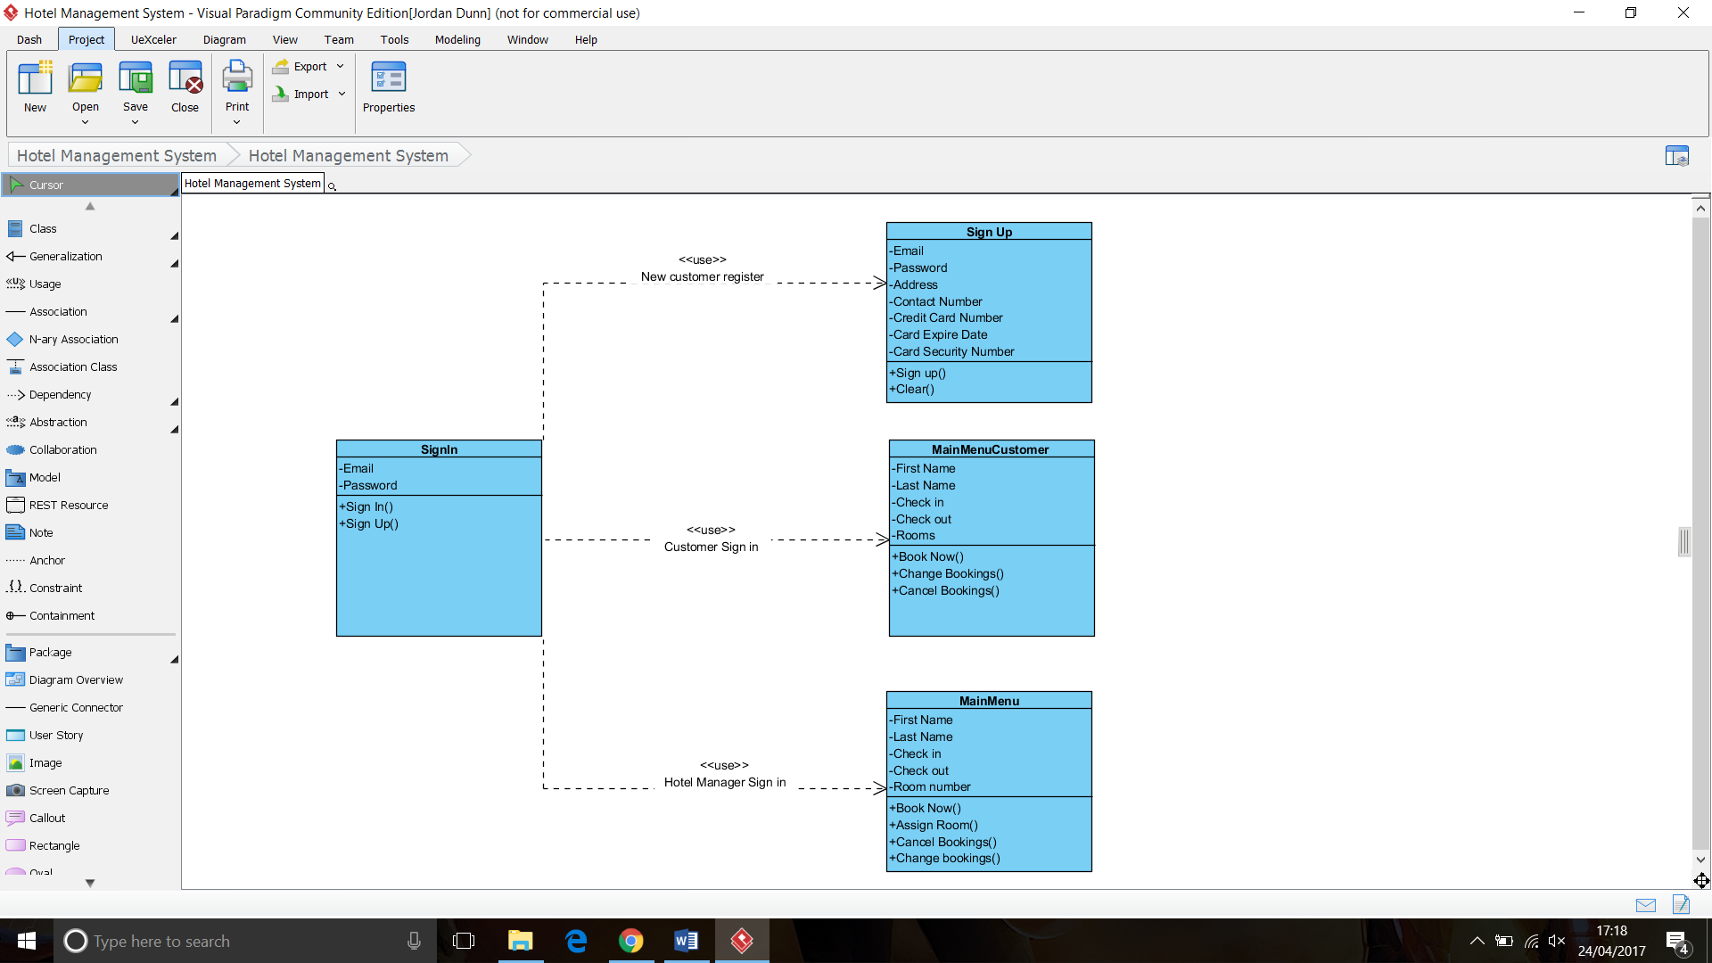

Figure 2: Hotel Booking System Class Diagram

The SignIn class is showing the attributes and the operations of the system that will be presented to both the customers and the members of staff from the Sign In screen. From this Sign In class, the customer can either Sign In or Sign Up. If the customer would like to Sign In, they will need to enter their Email Address and Password. If the customer would like to Sign Up, they will be able to do this by using the Sign Up function.

The Sign Up class is showing the different attributes and operations of the system that will be presented to the customer from the Sign Up screen. From this Sign Up class, the customer will be able to create an account by entering their Email Address, Password, Address, Contact Number, Credit Card Number, Card Expiry Date, and Card Security Number. Once these attributes have been entered, the customer will then be able to either Sign up or Clear the information present in the form.

The MainMenuCustomer class is showing the different attributes and operations of the system that will be presented to the customers from the Main Menu screen. From this Main Menu class, the customer will be able to make bookings by entering their First Name, Last Name, Check In Date, Check Out Date, and Room Size. Once these attributes have been entered, the customer will then be able to either Book Now, Change their booking, or Cancel their booking.

The MainMenu class shows the different attributes and operations of the system that will be presented to the users of the staff Main Menu screen. From this class, the members of staff will be able to make bookings by entering the customers First Name, Last Name, Check In Date, Check Out Date, Room Type, and Room Number. Once these have been entered, the member of staff will then be able to either Book Now, Assign Room, Cancel Booking, or Change Booking.

## Database Design

The database that was created for this program was created within phpMyAdmin. This database included two tables, these being bookings, and registercustomer. The way that we connected the system to the database was via XAMPP server.

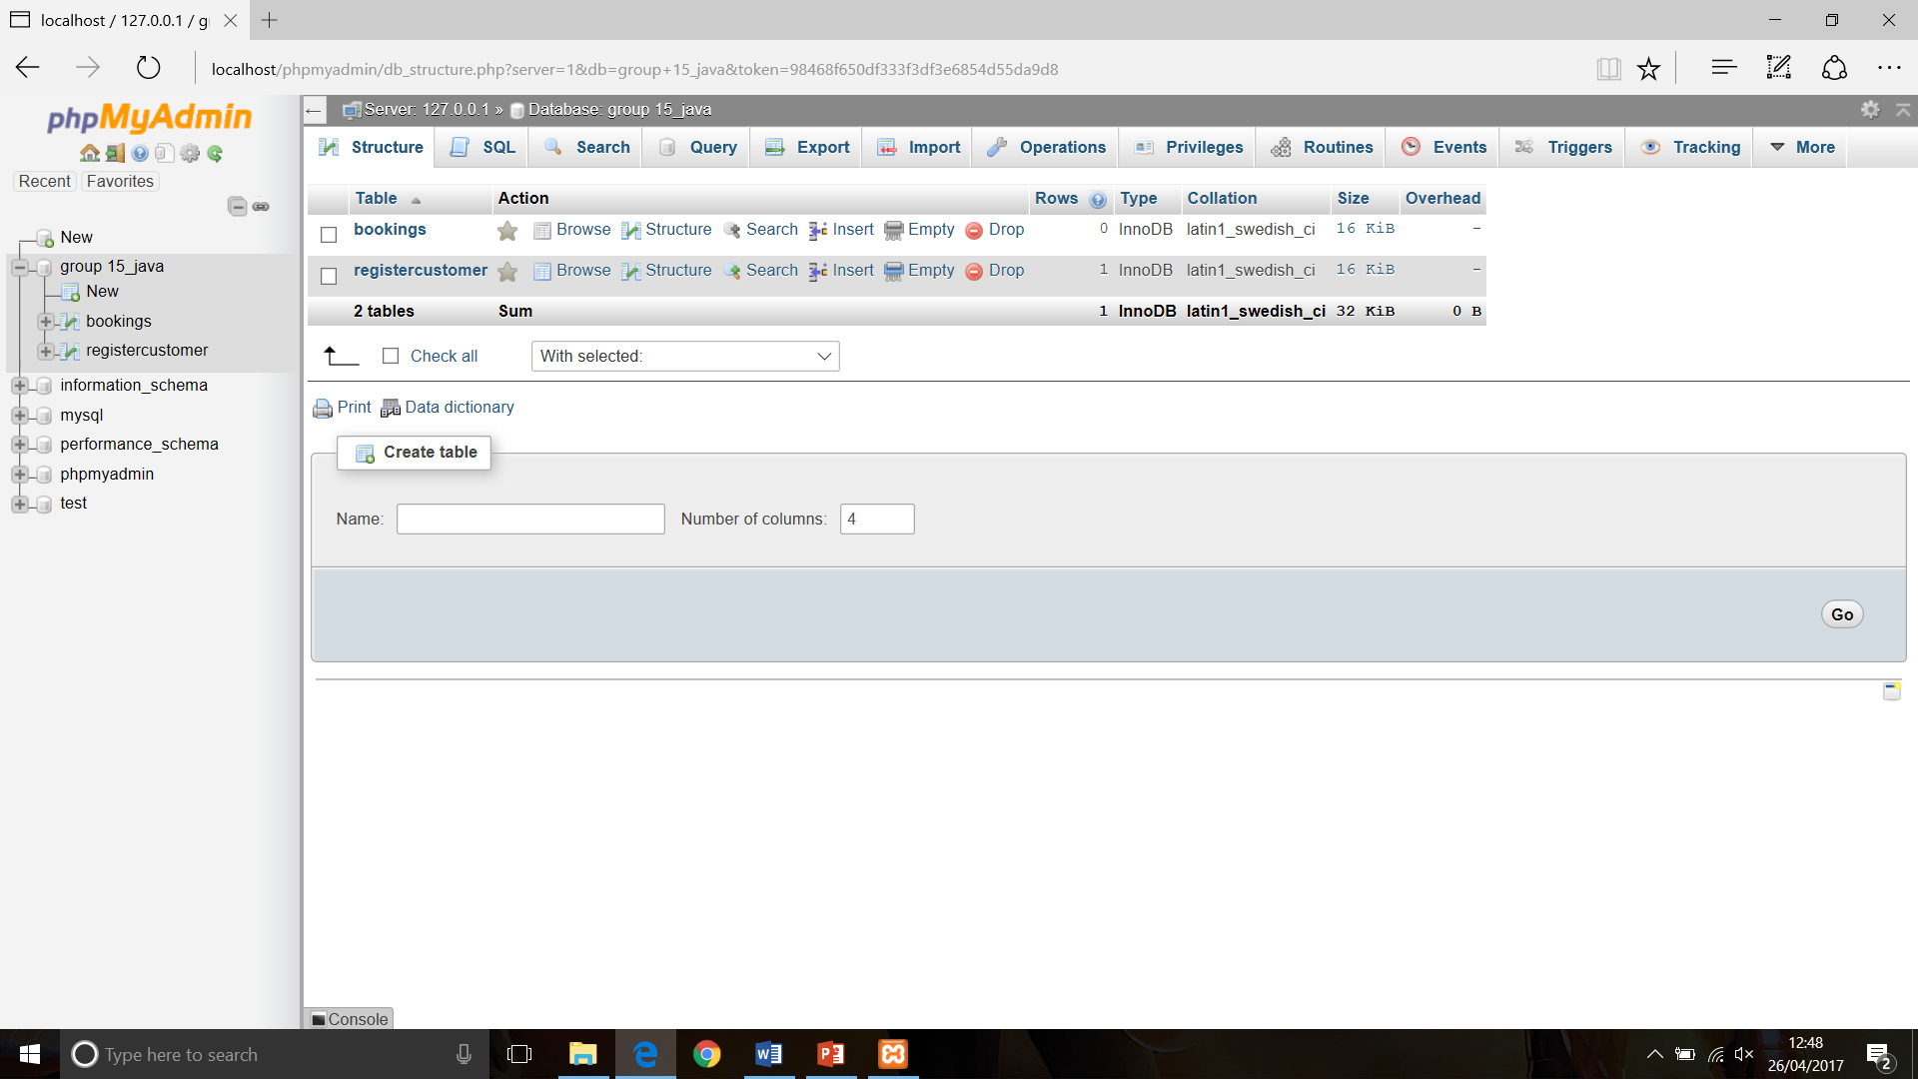

Within the bookings table there were 6 fields that were created. These were fname, lname, checkin, checkout, roomtype, and roomnumber. The fname, lname, checkin, checkout, and roomtype fields were all set as varchar, and had a size of 255. The roomnumber field was set as int, and had a size of 11.

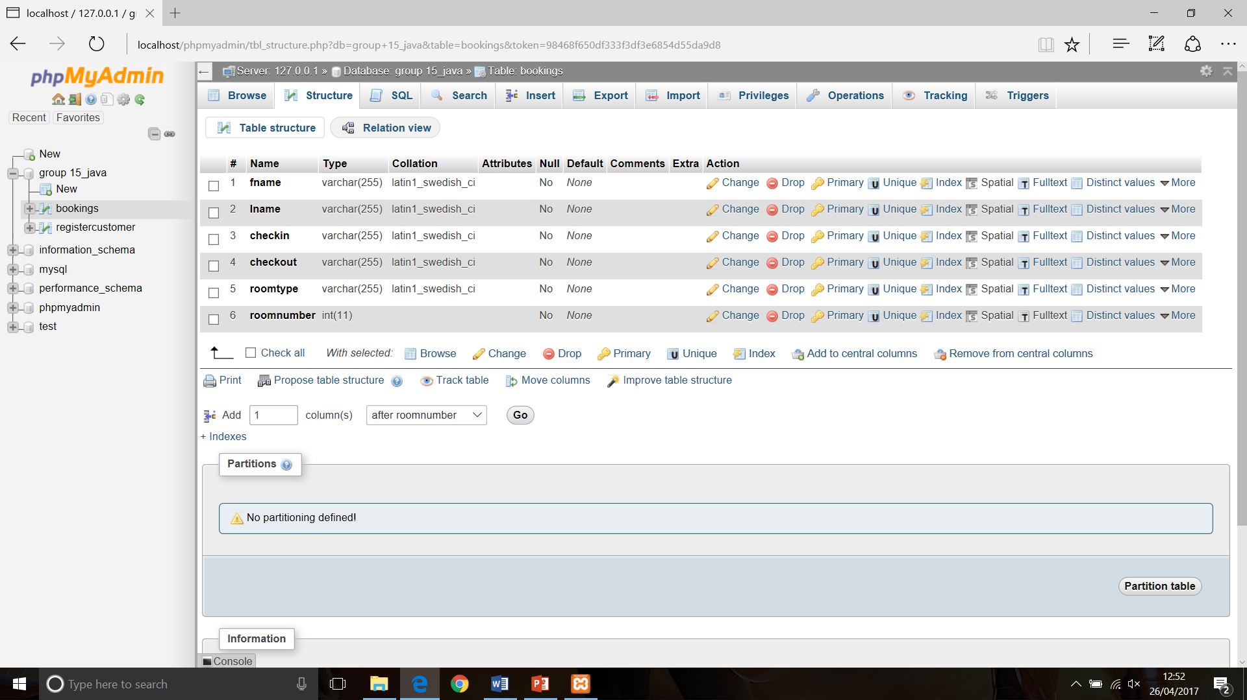

Within the registercustomer table there were also 6 fields that were created. These were email, password, address, card, exp, and security. The email, password, and address fields were all set as varchar, and had a size of 255. The card, exp, and security fields were set as int, and had a size of 11.

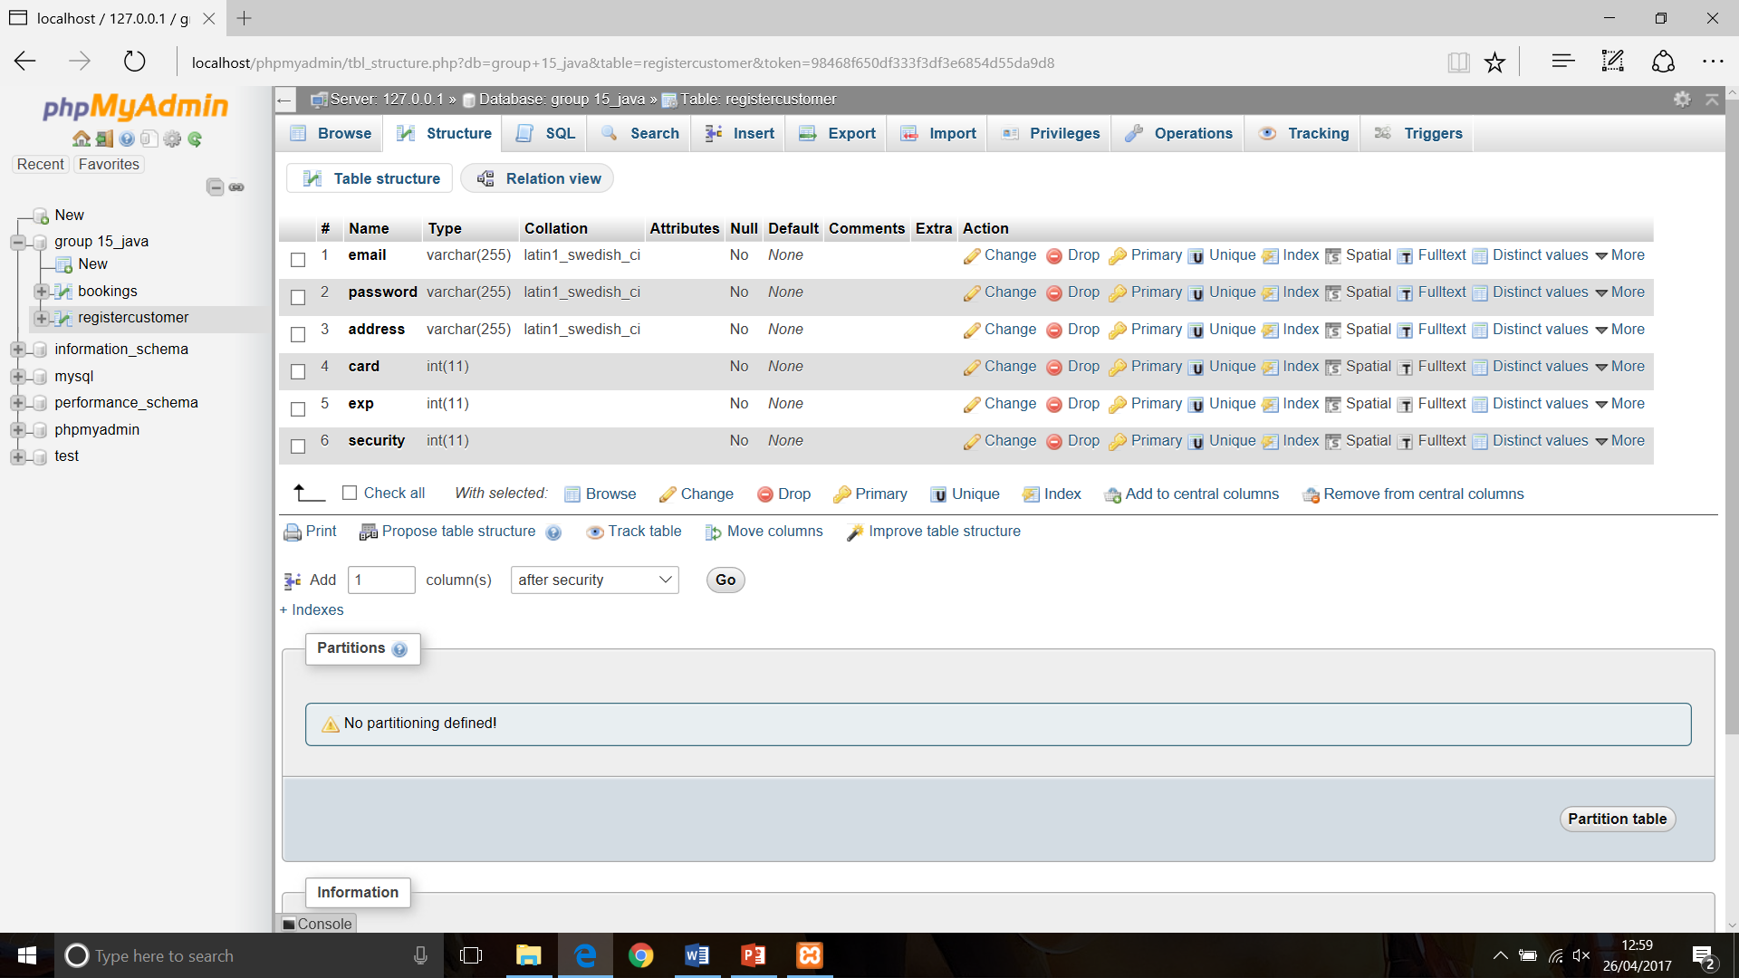

# Implementation

The IDE that we decided to use for this project was NetBeans. This was because NetBeans is widely used in the world of Java programming, and is very simple to use and to understand. There is also a huge amount of resources that are available online, making it easier to get help if any issues are encountered along the way of coding the system. Another reason that we decided to use NetBeans is because of the GUI Builder feature. This made our workload more efficient as it meant that we didn’t have to hard code features of the program such as buttons and text fields. The implementation method that was chosen was JDBC connector. This is because we felt that there wasn’t enough time for us to implement the socket programming for client-server, and left us more time to focus on the system itself. The system that has been created using the NetBeans IDE consists of four different pages. These pages include the User Sign-In page, Create New User page, Customer Booking Menu, and Admin Booking Menu page.

The User Sign-In page consists of two JButtons, four JLabels, one JPanel, one JPasswordField, and one JTextField.

The two JButtons on this page are ‘Sign-In’ and ‘Sign-Up’. When the ‘Sign-In’ button is clicked, the system will run a prepareStatement to check that the entered Email and Password match up to information on the database. If this information correctly matches up, the user will then be taken to the suitable main menu page. However, if this information does not correctly match up to the information in the database, an error will appear preventing the user to login to the system. When the ‘Sign-Up’ button is clicked, the user is taken to the ‘Create New User’ page.

The four JLabels that are used are ‘Welcome’, ‘Email:’, ‘Password:’, and ‘JLabel1’. The ‘JLabel1’ label is not visible on the Sign-In page as it is hidden behind the image. The JTextField and the JPasswordField are linked to the ‘Email:’ and ‘Password:’ JLabels, as this is where the Email and Password information should be entered.

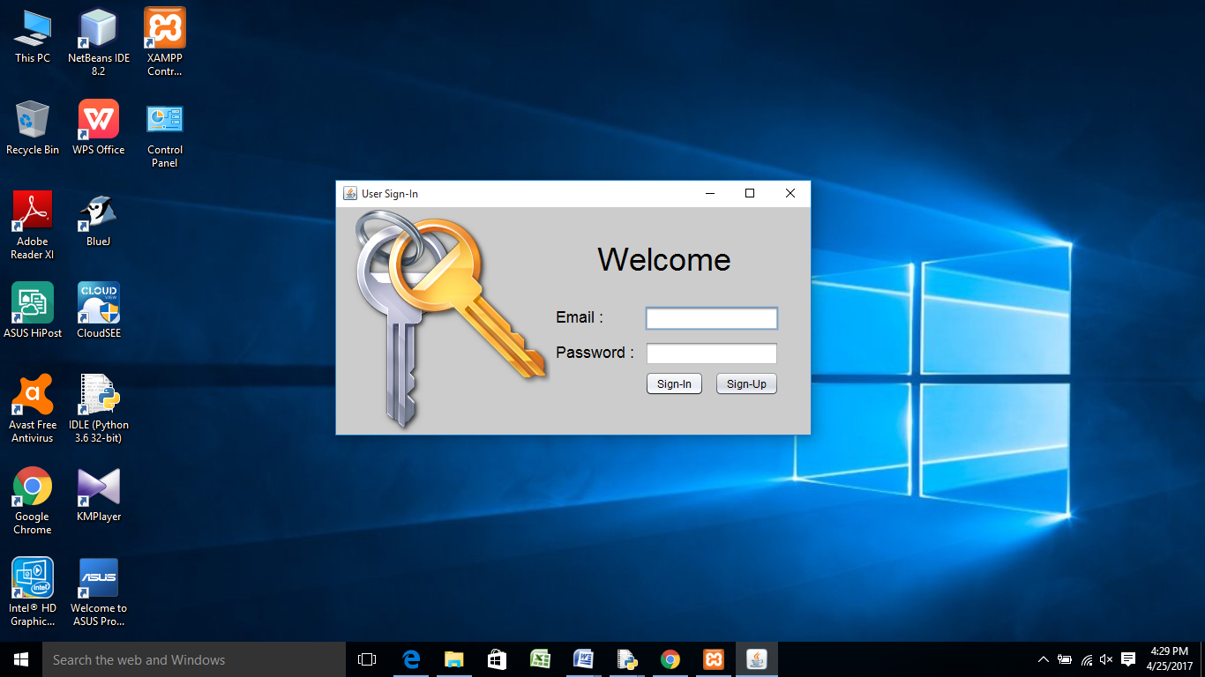

The Create New User page consists of two JButtons, six JLabels, one JPanel, one JPasswordField, and five JTextFields.

The two JButtons on this page are ‘Register’ and ‘Clear’. When the Register button is clicked, an insert query will be performed to take the information from the JTextFields, and add the new user to the database. When the ‘Clear’ button is clicked, the system simply updates the JTextFields to an empty string. This acts as a clear function as it removes all the information entered within the JTextFields.

The six JLabels that are used are ‘Email:’, ‘Password’, ‘Address:’, ‘Credit Card Number:’, ‘Card Expiry Date:’, and ‘Card Security Number:’. These JLabels are linked to the five JTextFields on this page, as this is where the user will enter the required information stated in the JLabels. The only JLabel that is not linked to a JTextField is the ‘Password:’ label. This is because this is linked with a JPasswordField.

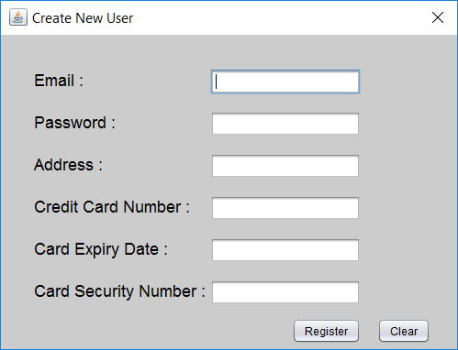

The Customer Booking Menu page consists of three JButtons, one JComboBox, two JDateChoosers, five JLabels, one JPanel, one JScrollPane, one JTable, and two JTextFields.

The three JButtons on this page are ‘Book Room’, ‘Change Booking’, and ‘Cancel Booking’. When the ‘Book Room’ button is clicked, the system will take the information provided in the JTextFields, JDateChoosers, and the JComboBox, and use an insert query to enter and store the information into the database. When the ‘Change Booking’ button is clicked, the system will take the edited information from the JTextFields, JDateChoosers, and the JComboBox, and use an update query to update and store the information in the database. When the ‘Cancel Booking’ button is clicked, the system will use a delete query to remove all the information related to the specific booking from the database.

The JComboBox on this page provides two options for the user to select when the function is used. The two options that are present are ‘Single’ and ‘Double’, which relate to the size of room that the customer can select.

The two JDateChoosers on this page have been used so that the customer is shown a calendar when selecting dates for their Check-In and Check-Out dates.

The five JLabels that are used are ‘First Name’, ‘Last Name’, ‘Check-In’, ‘Check-Out’, and ‘Room Type’. These JLabels are linked to the two JTextFields, two JDateChoosers, and the JComboBox, as this is where the customer will enter the information stated in the JLabels.

The JTable that is used on this page, is located underneath where the information needs to be entered. This is where the bookings that have been made by the customer will appear. With the help of Arrays, you can receive the text from the text fields so that they can be seen within the JTable. There is also a constructor class consisting of set and get methods on top of that.

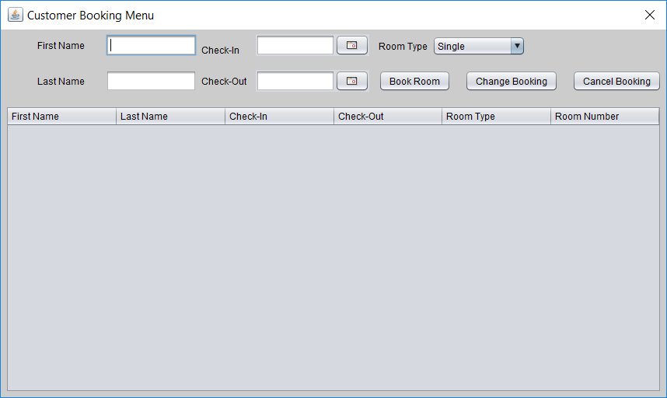

The Admin Booking Menu page consists of three JButtons, six JLabels, one JPanel, one JScrollPane, one JTable, and six JTextFields.

The three JButtons on this page are ‘Book Now’, ‘Change Booking’, and ‘Cancel Booking’. When the ‘Book Now’ button is clicked, the system will take the information provided in the JTextFields, and use an insert query to enter and store the information into the database. When the ‘Change Booking’ button is clicked, the system will take the edited information from the JTextFields, and use an update query to update and store the information in the database. This Update function is also required so that the admin can assign rooms to bookings made by customers. This is done by the admin selecting a booking from the JTable, and entering a room number into the JTextField. The ‘Change Booking’ button will then need to be clicked to update the record in the database. When the ‘Cancel Booking’ button is clicked, the system will use a delete query to remove all the information related to the specific booking from the database.

The six JLabels that are used within this page, are ‘First Name’, ‘Last Name’, ‘Check-In’, ‘Check-Out’, ‘Room Type’, and ‘Room Number’. These JLabels are linked to the six JTextFields on this page, as this is where the information stated in the JLabels will be held.

The JTable that is used on this page, is located underneath where the information needs to be entered. This is where all the bookings that have been made by all customers will appear for the Admin to view, and to make any changes to. With the help of Arrays, you can receive the text entered into the text fields by the customer, and also from the text fields of this page so that they can be seen within the JTable. There is also a constructor class consisting of set and get methods on top of that.

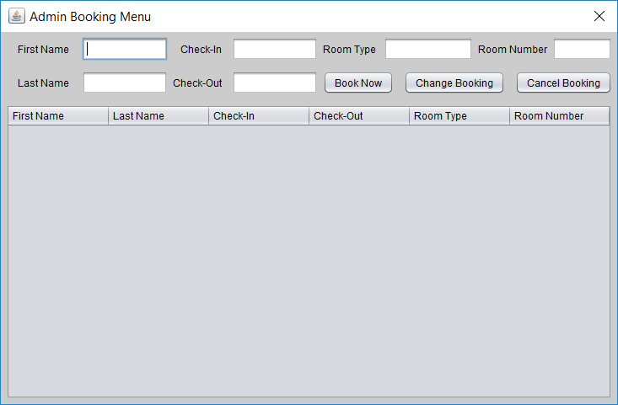

# Testing

We first tested that our code was working correctly by executing the program in NetBeans. This gave us the test log that is illustrated below, showing that the program runs successfully and complied in the IDE without any errors. The same results showed each time the program was run, proving the program is stable and running correctly. The testing was planned by executing the program, followed by testing each of the pages on the system, to ensure that it’s working as it should.

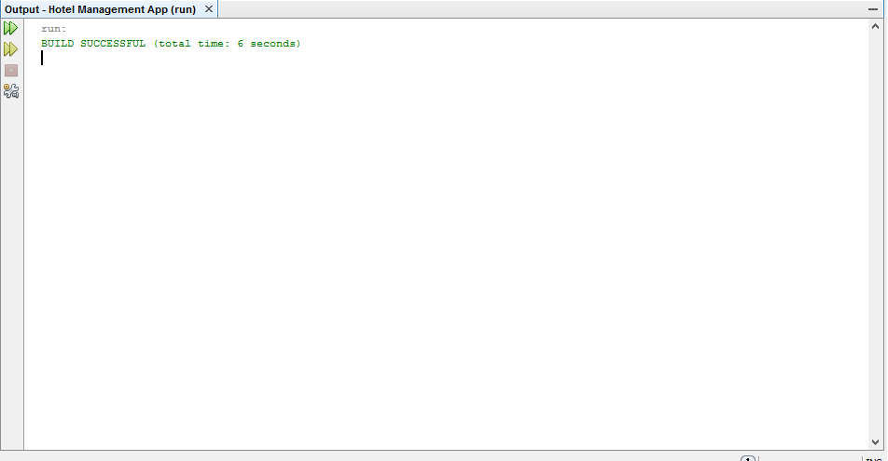

Here you can see the XAMPP server that we are using to connect our system to the database running successfully.

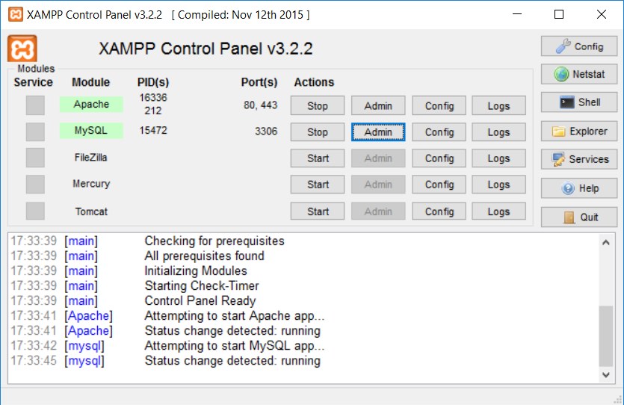

Below you can see that the Sign-Up button on the Sign-In page works correctly. This is shown as the Sign-Up page is opened once the button is clicked on by the user.

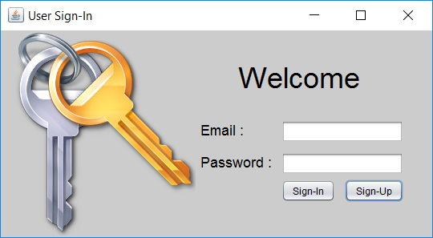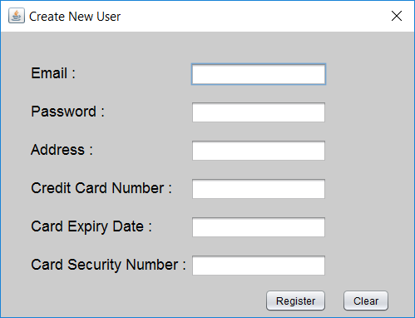

Here you can see us creating a new user for the system, by entering all the required information. As you can see, the “Register Inserted Successful” message appears once the ‘Register’ button has been clicked, showing that the user has successfully been created. I have also provided a screenshot below, showing that the users information has been saved within the database.

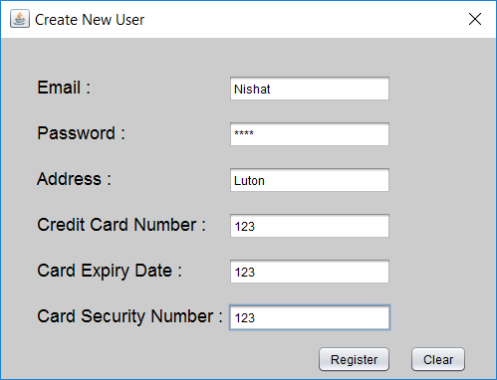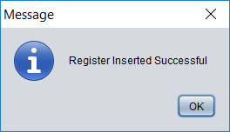

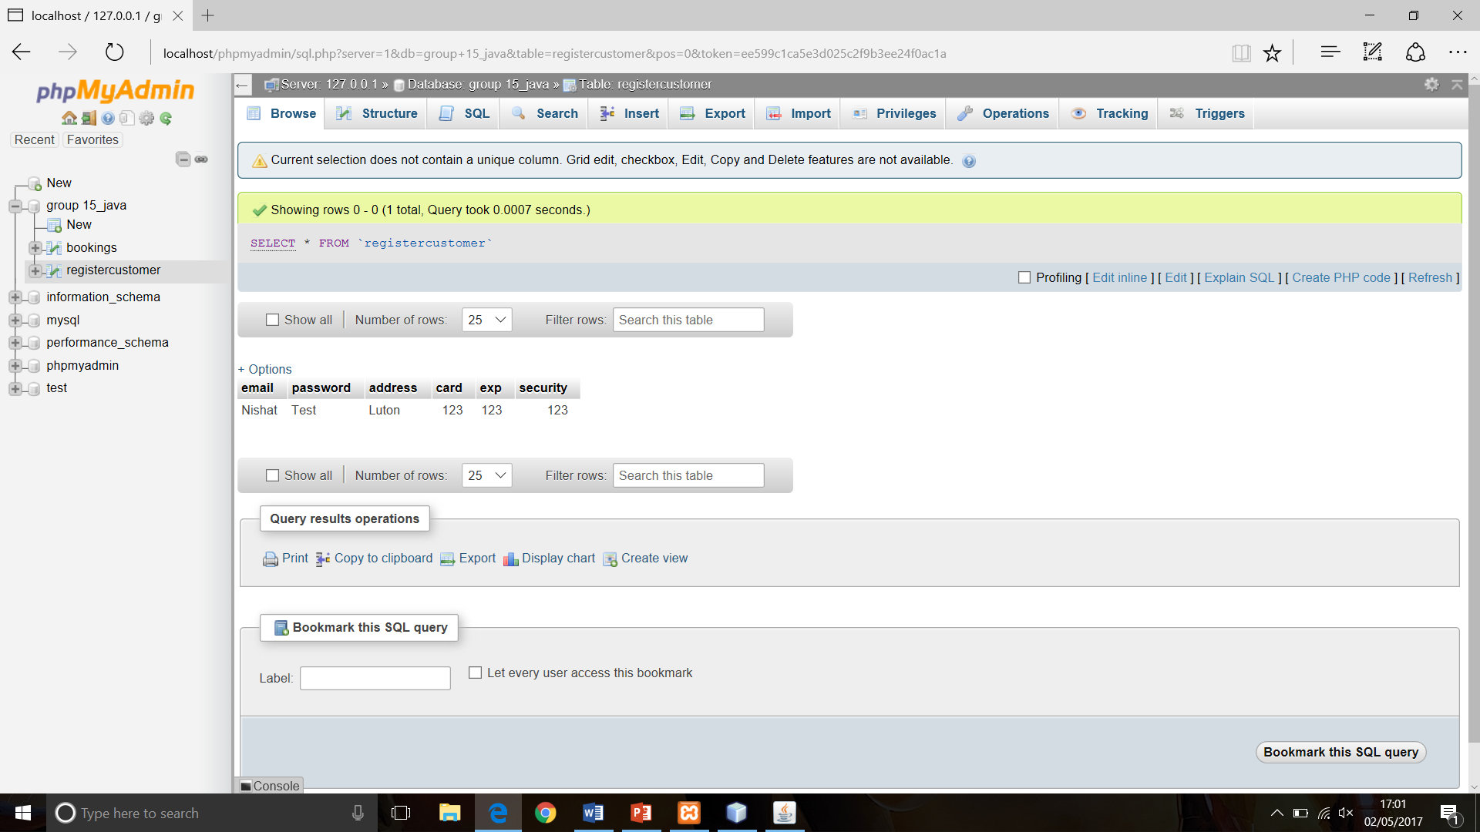

Below you can see the user attempting to login with an incorrect Email and Password. As you can see, once the ‘Sign-In’ button has been clicked, the “Sign-in failed!” error message appeared, showing that the user is unable to log into the system.

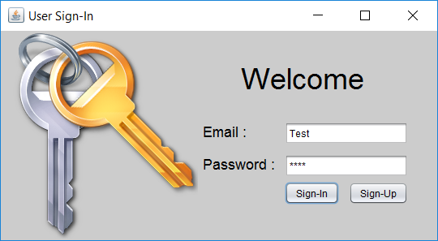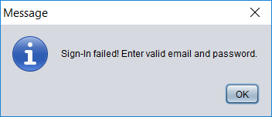

Here you can see the user attempting to login with the correct email address and password. This is to make sure that the system allows the user to successfully log into the system.

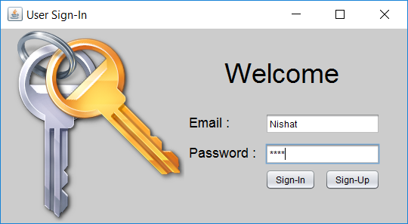

Below is the page that is shown to the customer once logged in. This shows that the previous login attempt was successful, and the customer has been granted access to the system.

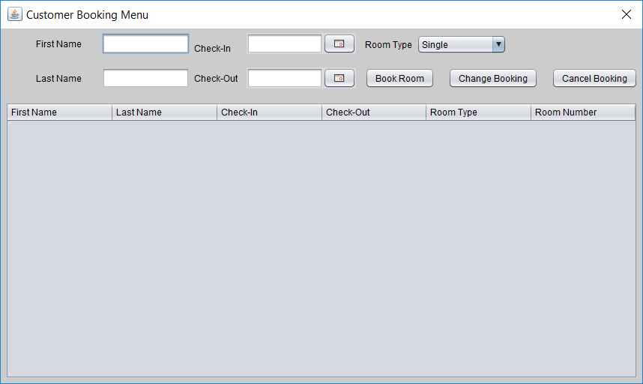

Here you can see a booking being made. The “Booking Inserted Successful” message then appears as confirmation of the booking being created. I have also provided a screenshot below, showing that the booking information has been saved within the database.

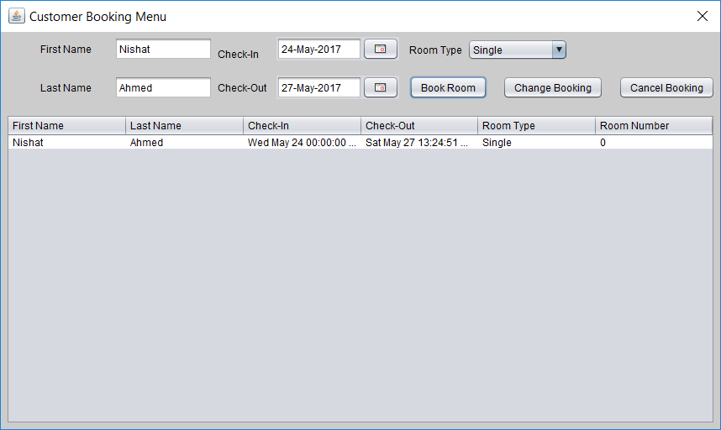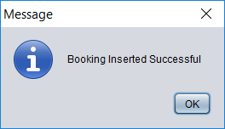



Below you can see the customer altering the booking, requesting a double room rather than a single room. Once the ‘Change Booking’ button has been clicked, the message “Booking Updated Successful” appears as confirmation that the booking has successfully been updated. I have also provided a screenshot below, showing that the booking information has been updated within the database.

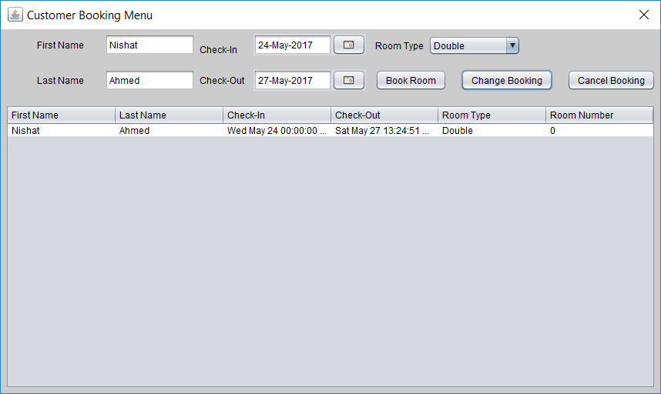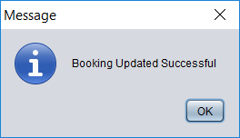

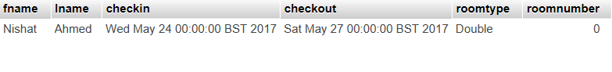

Here you can see that if the customer clicks on the ‘Cancel Booking’ button to remove their booking, a message appears saying “Booking Deleted Successful”. I have also provided a screenshot below showing that the booking information has been deleted from the database.

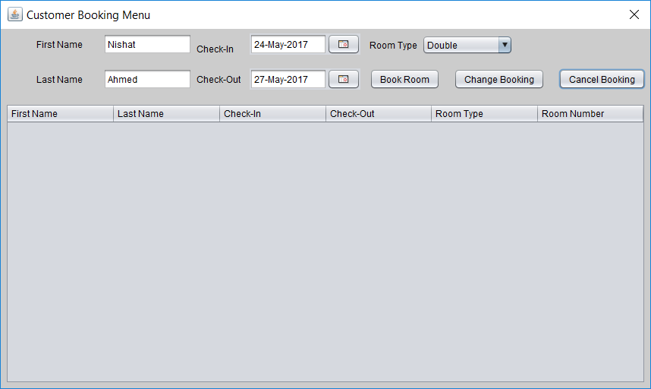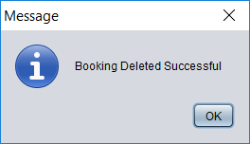



Below you can see the admin logging in with the correct password, this is to make sure that the system allows the admin to login successfully. The reason that we are testing this again, is because the login feature for the admin works differently as opposed to a customer. This is because the login details for the admin are hard coded meaning that there is no connection between the system and the database when a login attempt is made.

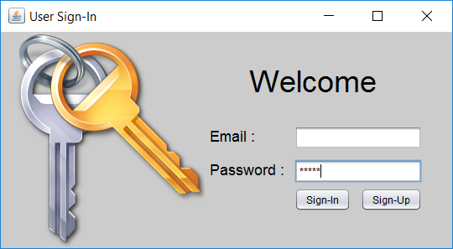

Here you can see the Admin Booking Menu that is shown upon a successful customer login attempt, showing that the previous login attempt was successful.



Below you can see the admin making a booking. After pressing the ‘Book Now’ button, the “Booking Inserted Successful” message appears as confirmation that the booking has successfully been inserted. As you can also see here, the Admin has the ability to view all bookings made by each customer. I have also provided a screenshot below, showing that the booking information has been entered into the database.

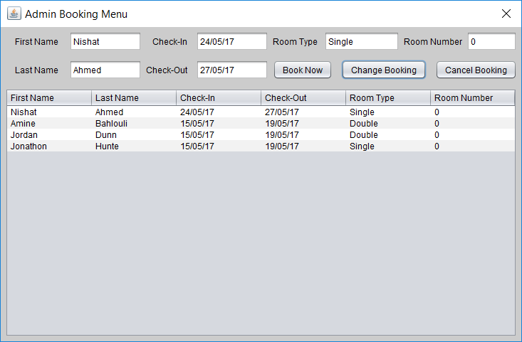

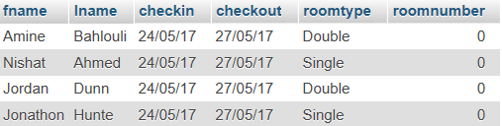

Here you can see that the admin altering the bookings, by assigning room numbers to the bookings on the system. Once the ‘Change Booking’ button has been clicked to update the information, a message saying, “Booking Updated Successful” is shown to the admin as confirmation of the change. I have also provided a screenshot below, showing that the booking information has been changed within the database.

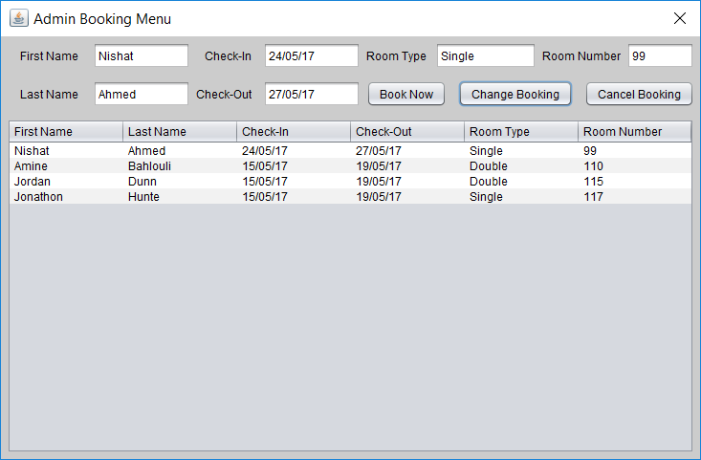

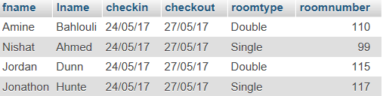

Below you can see that if the admin clicks on the ‘Cancel Booking’ button to remove a booking from the system, a message appears saying “Booking Deleted Successful”. I have also provided a screenshot below, showing that the one of the bookings have been deleted from within the database.

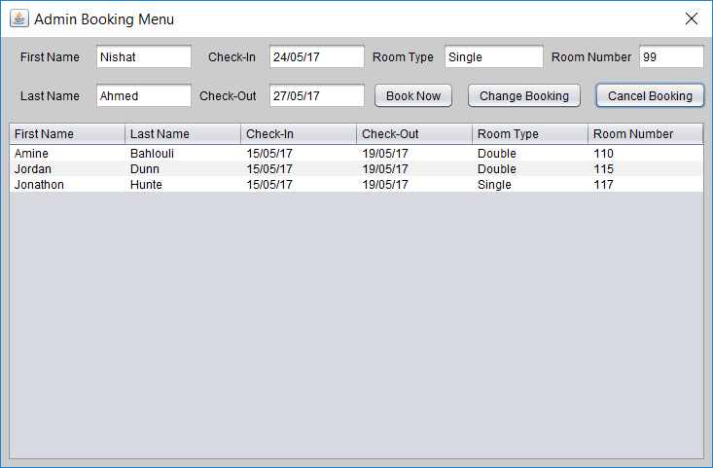

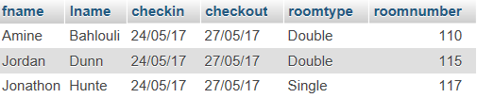

# Reflection and Responsibilities

Within this project, we all had our main roles. Nishat was the Group Leader, Jordan was the Front-End Developer, and looked after the Documentation, Jonathon did the MySQL Databases, and Amine was the Back-End Developer. Although these were our main roles, we all still got involved and contributed evenly on everything in the project. All members of the group got involved with the programming of the system, the database design and creation, and the documentation. Jordan created the Sign-Up page, Jonathon created the Sign-In page, Amine created the Admin Main Menu page, and Nishat created the Customer Booking page.

What went well with the group was the fact that everyone worked well together within the group, and each contributed 110% towards the project. All members of the group communicated well together, and any problems that occurred were quickly resolved by holding a group meetings. All the group members got on with each other well, which helped us to all work better together.

What didn’t go so well with the group was the fact that one group member suddenly stopped turning up to the meetings, and stopped communicating with us. The member then subsequently left the group. This unfortunately had a knock-on effect on the rest of the group, because it meant that there was an increased workload for all the other group members.

Table 1 Roles and Responsibilities

|  |  |
| --- | --- |
| **Name and ID** | **Roles** |
|  | Front-End Developer, Documentation |
|  | Group Leader |
|  | Database MySQL |
|  | Back-End Developer |

# Conclusion

In this report, we discussed the design and implementation of the Hotel Booking System, based on the specifications provided from the assignment brief. From looking at the use case diagram provided in the brief, we then based our class diagram off this.

For the class diagram, we took out everything we needed to include in the system, based on the specifications and implemented them into a class diagram.

We took the attributes from the class diagram and created a database with two tables, based on the information the customer would need to provide.

We took the class diagram and then created the different pages of the program, based on the attributes and methods used in the diagram.

After the program was built, the testing that we undertook concluded that the system works as it should. If you were to login with an incorrect email or password, you would get an error message and it will not allow you to login. It was confirmed that if you were to login with an incorrect username or password into admin, you would also get an error message. The testing also evidenced that making a new booking works at it should, as a new booking was added in for illustration purposes. The testing proved that the cancel booking button works as it should as well. The testing showed that the change booking button worked correctly as well, as it updates the existing booking. It confirms that when logging in as an admin, you can see all bookings in the admin booking menu. The testing proved that the change booking button works in the admin booking menu, as it showed you can upgrade a room type from a single to a double room. The assigning a room number to a booking works fine, as it was highlighted in the testing that you can assign a room number to a booking from the admin booking menu.

Everyone working together as a group worked very well, all members contributed fairly and work was disputed evenly between them.

# Appendix

**import** java**.**sql**.**Connection**;**

**import** java**.**sql**.**DriverManager**;**

**import** java**.**sql**.**PreparedStatement**;**

**import** java**.**sql**.**ResultSet**;**

**import** javax**.**swing**.**JOptionPane**;**

/*

* To change this license header, choose License Headers in Project Properties.

* To change this template file, choose Tools | Templates

* and open the template in the editor.

*/

/**

*

* **@author** Group 15

*/

public class LogIn **extends** javax**.**swing**.**JFrame **{**

/**

* Creates new form LogIn

*/

public LogIn**()** **{**

initComponents**();**

setLocationRelativeTo**(null);**

**}**

/**

* This method is called from within the constructor to initialize the form.

* WARNING: Do NOT modify this code. The content of this method is always

* regenerated by the Form Editor.

*/

@SuppressWarnings**(**"unchecked"**)**

// <editor-fold defaultstate="collapsed" desc="Generated Code">//GEN-BEGIN:initComponents

private void initComponents**()** **{**

jPanel1 **=** **new** javax**.**swing**.**JPanel**();**

jLabel1 **=** **new** javax**.**swing**.**JLabel**();**

jLabel2 **=** **new** javax**.**swing**.**JLabel**();**

jLabel3 **=** **new** javax**.**swing**.**JLabel**();**

jTextField_Email **=** **new** javax**.**swing**.**JTextField**();**

jPasswordField_Password **=** **new** javax**.**swing**.**JPasswordField**();**

jButton1 **=** **new** javax**.**swing**.**JButton**();**

jButton2 **=** **new** javax**.**swing**.**JButton**();**

jLabel4 **=** **new** javax**.**swing**.**JLabel**();**

setDefaultCloseOperation**(**javax**.**swing**.**WindowConstants**.**EXIT_ON_CLOSE**);**

setTitle**(**"User Sign-In"**);**

jPanel1**.**setBackground**(new** java**.**awt**.**Color**(**204**,** 204**,** 204**));**

jLabel1**.**setIcon**(new** javax**.**swing**.**ImageIcon**(**getClass**().**getResource**(**"/loginicon.png"**)));** // NOI18N

jLabel1**.**setText**(**"jLabel1"**);**

jLabel2**.**setFont**(new** java**.**awt**.**Font**(**"Dialog"**,** 0**,** 18**));** // NOI18N

jLabel2**.**setText**(**"Email :"**);**

jLabel3**.**setFont**(new** java**.**awt**.**Font**(**"Dialog"**,** 0**,** 18**));** // NOI18N

jLabel3**.**setText**(**"Password :"**);**

jButton1**.**setText**(**"Sign-In"**);**

jButton1**.**addActionListener**(new** java**.**awt**.**event**.**ActionListener**()** **{**

public void actionPerformed**(**java**.**awt**.**event**.**ActionEvent evt**)** **{**

jButton1ActionPerformed**(**evt**);**

**}**

**});**

jButton2**.**setText**(**"Sign-Up"**);**

jButton2**.**addActionListener**(new** java**.**awt**.**event**.**ActionListener**()** **{**

public void actionPerformed**(**java**.**awt**.**event**.**ActionEvent evt**)** **{**

jButton2ActionPerformed**(**evt**);**

**}**

**});**

jLabel4**.**setFont**(new** java**.**awt**.**Font**(**"Dialog"**,** 0**,** 36**));** // NOI18N

jLabel4**.**setText**(**"Welcome"**);**

javax**.**swing**.**GroupLayout jPanel1Layout **=** **new** javax**.**swing**.**GroupLayout**(**jPanel1**);**

jPanel1**.**setLayout**(**jPanel1Layout**);**

jPanel1Layout**.**setHorizontalGroup**(**

jPanel1Layout**.**createParallelGroup**(**javax**.**swing**.**GroupLayout**.**Alignment**.**LEADING**)**

**.**addGroup**(**jPanel1Layout**.**createSequentialGroup**()**

**.**addComponent**(**jLabel1**,** javax**.**swing**.**GroupLayout**.**PREFERRED_SIZE**,** 243**,** javax**.**swing**.**GroupLayout**.**PREFERRED_SIZE**)**

**.**addGroup**(**jPanel1Layout**.**createParallelGroup**(**javax**.**swing**.**GroupLayout**.**Alignment**.**LEADING**)**

**.**addGroup**(**jPanel1Layout**.**createSequentialGroup**()**

**.**addPreferredGap**(**javax**.**swing**.**LayoutStyle**.**ComponentPlacement**.**RELATED**)**

**.**addGroup**(**jPanel1Layout**.**createParallelGroup**(**javax**.**swing**.**GroupLayout**.**Alignment**.**TRAILING**)**

**.**addGroup**(**jPanel1Layout**.**createSequentialGroup**()**

**.**addGroup**(**jPanel1Layout**.**createParallelGroup**(**javax**.**swing**.**GroupLayout**.**Alignment**.**LEADING**)**

**.**addComponent**(**jLabel3**)**

**.**addComponent**(**jLabel2**))**

**.**addPreferredGap**(**javax**.**swing**.**LayoutStyle**.**ComponentPlacement**.**UNRELATED**)**

**.**addGroup**(**jPanel1Layout**.**createParallelGroup**(**javax**.**swing**.**GroupLayout**.**Alignment**.**LEADING**)**

**.**addComponent**(**jTextField_Email**)**

**.**addComponent**(**jPasswordField_Password**)))**

**.**addGroup**(**jPanel1Layout**.**createSequentialGroup**()**

**.**addGap**(**0**,** 101**,** Short**.**MAX_VALUE**)**

**.**addComponent**(**jButton1**)**

**.**addPreferredGap**(**javax**.**swing**.**LayoutStyle**.**ComponentPlacement**.**UNRELATED**)**

**.**addComponent**(**jButton2**)))**

**.**addGap**(**36**,** 36**,** 36**))**

**.**addGroup**(**jPanel1Layout**.**createSequentialGroup**()**

**.**addGap**(**53**,** 53**,** 53**)**

**.**addComponent**(**jLabel4**)**

**.**addContainerGap**(**javax**.**swing**.**GroupLayout**.**DEFAULT_SIZE**,** Short**.**MAX_VALUE**))))**

**);**

jPanel1Layout**.**setVerticalGroup**(**

jPanel1Layout**.**createParallelGroup**(**javax**.**swing**.**GroupLayout**.**Alignment**.**LEADING**)**

**.**addGroup**(**jPanel1Layout**.**createSequentialGroup**()**

**.**addComponent**(**jLabel1**)**

**.**addGap**(**0**,** 0**,** Short**.**MAX_VALUE**))**

**.**addGroup**(**jPanel1Layout**.**createSequentialGroup**()**

**.**addGap**(**35**,** 35**,** 35**)**

**.**addComponent**(**jLabel4**)**

**.**addGap**(**30**,** 30**,** 30**)**

**.**addGroup**(**jPanel1Layout**.**createParallelGroup**(**javax**.**swing**.**GroupLayout**.**Alignment**.**BASELINE**)**

**.**addComponent**(**jLabel2**)**

**.**addComponent**(**jTextField_Email**,** javax**.**swing**.**GroupLayout**.**PREFERRED_SIZE**,** javax**.**swing**.**GroupLayout**.**DEFAULT_SIZE**,** javax**.**swing**.**GroupLayout**.**PREFERRED_SIZE**))**

**.**addPreferredGap**(**javax**.**swing**.**LayoutStyle**.**ComponentPlacement**.**UNRELATED**)**

**.**addGroup**(**jPanel1Layout**.**createParallelGroup**(**javax**.**swing**.**GroupLayout**.**Alignment**.**BASELINE**)**

**.**addComponent**(**jLabel3**)**

**.**addComponent**(**jPasswordField_Password**,** javax**.**swing**.**GroupLayout**.**PREFERRED_SIZE**,** javax**.**swing**.**GroupLayout**.**DEFAULT_SIZE**,** javax**.**swing**.**GroupLayout**.**PREFERRED_SIZE**))**

**.**addPreferredGap**(**javax**.**swing**.**LayoutStyle**.**ComponentPlacement**.**RELATED**,** javax**.**swing**.**GroupLayout**.**DEFAULT_SIZE**,** Short**.**MAX_VALUE**)**

**.**addGroup**(**jPanel1Layout**.**createParallelGroup**(**javax**.**swing**.**GroupLayout**.**Alignment**.**BASELINE**)**

**.**addComponent**(**jButton2**)**

**.**addComponent**(**jButton1**))**

**.**addGap**(**44**,** 44**,** 44**))**

**);**

javax**.**swing**.**GroupLayout layout **=** **new** javax**.**swing**.**GroupLayout**(**getContentPane**());**

getContentPane**().**setLayout**(**layout**);**

layout**.**setHorizontalGroup**(**

layout**.**createParallelGroup**(**javax**.**swing**.**GroupLayout**.**Alignment**.**LEADING**)**

**.**addComponent**(**jPanel1**,** javax**.**swing**.**GroupLayout**.**DEFAULT_SIZE**,** javax**.**swing**.**GroupLayout**.**DEFAULT_SIZE**,** Short**.**MAX_VALUE**)**

**);**

layout**.**setVerticalGroup**(**

layout**.**createParallelGroup**(**javax**.**swing**.**GroupLayout**.**Alignment**.**LEADING**)**

**.**addComponent**(**jPanel1**,** javax**.**swing**.**GroupLayout**.**DEFAULT_SIZE**,** javax**.**swing**.**GroupLayout**.**DEFAULT_SIZE**,** Short**.**MAX_VALUE**)**

**);**

pack**();**

**}**// </editor-fold>//GEN-END:initComponents

private void jButton2ActionPerformed**(**java**.**awt**.**event**.**ActionEvent evt**)** **{**//GEN-FIRST:event_jButton2ActionPerformed

Register menu **=** **new** Register**(this,** **true);**

menu**.**setVisible**(true);**

**}**//GEN-LAST:event_jButton2ActionPerformed

private void jButton1ActionPerformed**(**java**.**awt**.**event**.**ActionEvent evt**)** **{**//GEN-FIRST:event_jButton1ActionPerformed

//Verify admin sign in process

**if(**jPasswordField_Password**.**getText**().**matches**(**"admin"**)){**

MainMenu menu **=** **new** MainMenu**(this,true);**

menu**.**setVisible**(true);**

jPasswordField_Password**.**setText**(**""**);**

**}**

//mySQL users

Connection connection**;**

PreparedStatement ps**;**

**try{**

connection **=** DriverManager**.**getConnection**(**"jdbc:mysql://localhost/group 15_java"**,**"root"**,**""**);**

ps**=** connection**.**prepareStatement**(**"SELECT email , password FROM registercustomer WHERE email =? AND password = ?"**);**

ps**.**setString**(**1**,** jTextField_Email**.**getText**());**

ps**.**setString**(**2**,** jPasswordField_Password**.**getText**());**

ResultSet result **=** ps**.**executeQuery**();**

**if(**result**.**next**()){**

MainMenuCustomer menu **=** **new** MainMenuCustomer**(null,** **true);**

menu**.**setVisible**(true);**

jTextField_Email**.**setText**(**""**);**

jPasswordField_Password**.**setText**(**""**);**

**}**

**else{**

JOptionPane**.**showMessageDialog**(null,** "Sign-In failed! Enter valid email and password. "**);**

**}**

**}catch** **(**Exception e**){**

e**.**printStackTrace**();**

**}**

**}**//GEN-LAST:event_jButton1ActionPerformed

/**

* **@param** args the command line arguments

*/

public static void main**(**String args**[])** **{**

/* Set the Nimbus look and feel */

//<editor-fold defaultstate="collapsed" desc=" Look and feel setting code (optional) ">

/* If Nimbus (introduced in Java SE 6) is not available, stay with the default look and feel.

* For details see http://download.oracle.com/javase/tutorial/uiswing/lookandfeel/plaf.html

*/

**try** **{**

**for** **(**javax**.**swing**.**UIManager**.**LookAndFeelInfo info **:** javax**.**swing**.**UIManager**.**getInstalledLookAndFeels**())** **{**

**if** **(**"Nimbus"**.**equals**(**info**.**getName**()))** **{**

javax**.**swing**.**UIManager**.**setLookAndFeel**(**info**.**getClassName**());**

**break;**

**}**

**}**

**}** **catch** **(**ClassNotFoundException ex**)** **{**

java**.**util**.**logging**.**Logger**.**getLogger**(**LogIn**.**class**.**getName**()).**log**(**java**.**util**.**logging**.**Level**.**SEVERE**,** **null,** ex**);**

**}** **catch** **(**InstantiationException ex**)** **{**

java**.**util**.**logging**.**Logger**.**getLogger**(**LogIn**.**class**.**getName**()).**log**(**java**.**util**.**logging**.**Level**.**SEVERE**,** **null,** ex**);**

**}** **catch** **(**IllegalAccessException ex**)** **{**

java**.**util**.**logging**.**Logger**.**getLogger**(**LogIn**.**class**.**getName**()).**log**(**java**.**util**.**logging**.**Level**.**SEVERE**,** **null,** ex**);**

**}** **catch** **(**javax**.**swing**.**UnsupportedLookAndFeelException ex**)** **{**

java**.**util**.**logging**.**Logger**.**getLogger**(**LogIn**.**class**.**getName**()).**log**(**java**.**util**.**logging**.**Level**.**SEVERE**,** **null,** ex**);**

**}**

//</editor-fold>

/* Create and display the form */

java**.**awt**.**EventQueue**.**invokeLater**(new** Runnable**()** **{**

public void run**()** **{**

**new** LogIn**().**setVisible**(true);**

**}**

**});**

**}**

// Variables declaration - do not modify//GEN-BEGIN:variables

private javax**.**swing**.**JButton jButton1**;**

private javax**.**swing**.**JButton jButton2**;**

private javax**.**swing**.**JLabel jLabel1**;**

private javax**.**swing**.**JLabel jLabel2**;**

private javax**.**swing**.**JLabel jLabel3**;**

private javax**.**swing**.**JLabel jLabel4**;**

private javax**.**swing**.**JPanel jPanel1**;**

private javax**.**swing**.**JPasswordField jPasswordField_Password**;**

private javax**.**swing**.**JTextField jTextField_Email**;**

// End of variables declaration//GEN-END:variables

**}**

/*

* To change this license header, choose License Headers in Project Properties.

* To change this template file, choose Tools | Templates

* and open the template in the editor.

*/

/**

*

* **@author** Group 15

*/

public class registerCustomer **{**

private String email**;**

private String password**;**

private String address**;**

private String credit**;**

private String exp**;**

private String security**;**

public registerCustomer **(**String Email**,** String Password**,** String Address**,** String Credit**,** String Exp**,** String Security**){**

**this.**email **=** Email**;**

**this.**password **=** Password**;**

**this.**address **=** Address**;**

**this.**credit **=** Credit**;**

**this.**exp **=** Exp**;**

**this.**security **=** Security**;**

**}**

public String getEmail**(){**

**return** email**;**

**}**

public String getPassword**(){**

**return** password**;**

**}**

public String getAddress**(){**

**return** address**;**

**}**

public String getCredit**(){**

**return** credit**;**

**}**

public String getExp**(){**

**return** exp**;**

**}**

public String getSecurity**(){**

**return** security**;**

**}**

**}**

**import** java**.**sql**.**Connection**;**

**import** java**.**sql**.**DriverManager**;**

**import** java**.**sql**.**Statement**;**

**import** javax**.**swing**.**JOptionPane**;**

/*

* To change this license header, choose License Headers in Project Properties.

* To change this template file, choose Tools | Templates

* and open the template in the editor.

*/

/**

*

* **@author** Group 15

*/

public class Register **extends** javax**.**swing**.**JDialog **{**

/**

* Creates new form Register

*/

public Register**(**java**.**awt**.**Frame parent**,** boolean modal**)** **{**

**super(**parent**,** modal**);**

initComponents**();**

setLocationRelativeTo**(null);**

**}**

public Connection getConnection**(){**

Connection con**;**

**try{**

con **=** DriverManager**.**getConnection**(**"jdbc:mysql://localhost/group 15_java"**,**"root"**,**""**);**

**return** con**;**

**}catch** **(**Exception e**){**

e**.**printStackTrace**();**

**return** **null;**

**}**

**}**

public void executeSQlQuery**(**String query**,** String message**)**

**{**

Connection con **=** getConnection**();**

Statement st**;**

**try{**

st **=** con**.**createStatement**();**

**if((**st**.**executeUpdate**(**query**))** **==** 1**)**

**{**

JOptionPane**.**showMessageDialog**(null,** "Register "**+**message**+**" Successful"**);**

MainMenuCustomer menu **=** **new** MainMenuCustomer**(null,** **true);**

menu**.**setVisible**(true);**

**}else{**

JOptionPane**.**showMessageDialog**(null,** "Register Not "**+**message**);**

**}**

**}** **catch(**Exception ex**){**

ex**.**printStackTrace**();**

**}**

**}**

/**

* This method is called from within the constructor to initialize the form.

* WARNING: Do NOT modify this code. The content of this method is always

* regenerated by the Form Editor.

*/

@SuppressWarnings**(**"unchecked"**)**

// <editor-fold defaultstate="collapsed" desc="Generated Code">//GEN-BEGIN:initComponents

private void initComponents**()** **{**

jPanel1 **=** **new** javax**.**swing**.**JPanel**();**

jLabel1 **=** **new** javax**.**swing**.**JLabel**();**

jLabel2 **=** **new** javax**.**swing**.**JLabel**();**

jLabel3 **=** **new** javax**.**swing**.**JLabel**();**

jLabel4 **=** **new** javax**.**swing**.**JLabel**();**

jLabel5 **=** **new** javax**.**swing**.**JLabel**();**

jLabel6 **=** **new** javax**.**swing**.**JLabel**();**

jButton_Insert **=** **new** javax**.**swing**.**JButton**();**

jButton_Clear **=** **new** javax**.**swing**.**JButton**();**

jTextField_Email **=** **new** javax**.**swing**.**JTextField**();**

jTextField_Exp **=** **new** javax**.**swing**.**JTextField**();**

jTextField_Credit **=** **new** javax**.**swing**.**JTextField**();**

jTextField_Address **=** **new** javax**.**swing**.**JTextField**();**

jTextField_Security **=** **new** javax**.**swing**.**JTextField**();**

jPasswordField_Password **=** **new** javax**.**swing**.**JPasswordField**();**

setDefaultCloseOperation**(**javax**.**swing**.**WindowConstants**.**DISPOSE_ON_CLOSE**);**

setTitle**(**"Create New User"**);**

jPanel1**.**setBackground**(new** java**.**awt**.**Color**(**204**,** 204**,** 204**));**

jLabel1**.**setFont**(new** java**.**awt**.**Font**(**"Dialog"**,** 0**,** 18**));** // NOI18N

jLabel1**.**setText**(**"Email :"**);**

jLabel2**.**setFont**(new** java**.**awt**.**Font**(**"Dialog"**,** 0**,** 18**));** // NOI18N

jLabel2**.**setText**(**"Password :"**);**

jLabel3**.**setFont**(new** java**.**awt**.**Font**(**"Dialog"**,** 0**,** 18**));** // NOI18N

jLabel3**.**setText**(**"Address :"**);**

jLabel4**.**setFont**(new** java**.**awt**.**Font**(**"Dialog"**,** 0**,** 18**));** // NOI18N

jLabel4**.**setText**(**"Credit Card Number :"**);**

jLabel5**.**setFont**(new** java**.**awt**.**Font**(**"Dialog"**,** 0**,** 18**));** // NOI18N

jLabel5**.**setText**(**"Card Expiry Date :"**);**

jLabel6**.**setFont**(new** java**.**awt**.**Font**(**"Dialog"**,** 0**,** 18**));** // NOI18N

jLabel6**.**setText**(**"Card Security Number :"**);**

jButton_Insert**.**setText**(**"Register"**);**

jButton_Insert**.**addActionListener**(new** java**.**awt**.**event**.**ActionListener**()** **{**

public void actionPerformed**(**java**.**awt**.**event**.**ActionEvent evt**)** **{**

jButton_InsertActionPerformed**(**evt**);**

**}**

**});**

jButton_Clear**.**setText**(**"Clear"**);**

jButton_Clear**.**addActionListener**(new** java**.**awt**.**event**.**ActionListener**()** **{**

public void actionPerformed**(**java**.**awt**.**event**.**ActionEvent evt**)** **{**

jButton_ClearActionPerformed**(**evt**);**

**}**

**});**

javax**.**swing**.**GroupLayout jPanel1Layout **=** **new** javax**.**swing**.**GroupLayout**(**jPanel1**);**

jPanel1**.**setLayout**(**jPanel1Layout**);**

jPanel1Layout**.**setHorizontalGroup**(**

jPanel1Layout**.**createParallelGroup**(**javax**.**swing**.**GroupLayout**.**Alignment**.**LEADING**)**

**.**addGroup**(**javax**.**swing**.**GroupLayout**.**Alignment**.**TRAILING**,** jPanel1Layout**.**createSequentialGroup**()**

**.**addGroup**(**jPanel1Layout**.**createParallelGroup**(**javax**.**swing**.**GroupLayout**.**Alignment**.**TRAILING**)**

**.**addGroup**(**javax**.**swing**.**GroupLayout**.**Alignment**.**LEADING**,** jPanel1Layout**.**createSequentialGroup**()**

**.**addGap**(**36**,** 36**,** 36**)**

**.**addGroup**(**jPanel1Layout**.**createParallelGroup**(**javax**.**swing**.**GroupLayout**.**Alignment**.**LEADING**)**

**.**addComponent**(**jLabel2**)**

**.**addComponent**(**jLabel5**)**

**.**addGroup**(**jPanel1Layout**.**createParallelGroup**(**javax**.**swing**.**GroupLayout**.**Alignment**.**TRAILING**)**

**.**addComponent**(**jLabel1**,** javax**.**swing**.**GroupLayout**.**Alignment**.**LEADING**)**

**.**addComponent**(**jLabel6**))**

**.**addComponent**(**jLabel3**)**

**.**addComponent**(**jLabel4**))**

**.**addGap**(**5**,** 5**,** 5**)**

**.**addGroup**(**jPanel1Layout**.**createParallelGroup**(**javax**.**swing**.**GroupLayout**.**Alignment**.**LEADING**)**

**.**addComponent**(**jTextField_Credit**)**

**.**addComponent**(**jTextField_Email**)**

**.**addComponent**(**jTextField_Address**)**

**.**addComponent**(**jTextField_Exp**)**

**.**addComponent**(**jTextField_Security**)**

**.**addComponent**(**jPasswordField_Password**,** javax**.**swing**.**GroupLayout**.**DEFAULT_SIZE**,** 164**,** Short**.**MAX_VALUE**)))**

**.**addGroup**(**jPanel1Layout**.**createSequentialGroup**()**

**.**addContainerGap**(**javax**.**swing**.**GroupLayout**.**DEFAULT_SIZE**,** Short**.**MAX_VALUE**)**

**.**addComponent**(**jButton_Insert**)))**

**.**addGap**(**18**,** 18**,** 18**)**

**.**addComponent**(**jButton_Clear**)**

**.**addGap**(**29**,** 29**,** 29**))**

**);**

jPanel1Layout**.**setVerticalGroup**(**

jPanel1Layout**.**createParallelGroup**(**javax**.**swing**.**GroupLayout**.**Alignment**.**LEADING**)**

**.**addGroup**(**jPanel1Layout**.**createSequentialGroup**()**

**.**addGap**(**37**,** 37**,** 37**)**

**.**addGroup**(**jPanel1Layout**.**createParallelGroup**(**javax**.**swing**.**GroupLayout**.**Alignment**.**BASELINE**)**

**.**addComponent**(**jLabel1**)**

**.**addComponent**(**jTextField_Email**,** javax**.**swing**.**GroupLayout**.**PREFERRED_SIZE**,** javax**.**swing**.**GroupLayout**.**DEFAULT_SIZE**,** javax**.**swing**.**GroupLayout**.**PREFERRED_SIZE**))**

**.**addGap**(**18**,** 18**,** 18**)**

**.**addGroup**(**jPanel1Layout**.**createParallelGroup**(**javax**.**swing**.**GroupLayout**.**Alignment**.**BASELINE**)**

**.**addComponent**(**jLabel2**)**

**.**addComponent**(**jPasswordField_Password**,** javax**.**swing**.**GroupLayout**.**PREFERRED_SIZE**,** javax**.**swing**.**GroupLayout**.**DEFAULT_SIZE**,** javax**.**swing**.**GroupLayout**.**PREFERRED_SIZE**))**

**.**addGap**(**18**,** 18**,** 18**)**

**.**addGroup**(**jPanel1Layout**.**createParallelGroup**(**javax**.**swing**.**GroupLayout**.**Alignment**.**BASELINE**)**

**.**addComponent**(**jLabel3**)**

**.**addComponent**(**jTextField_Address**,** javax**.**swing**.**GroupLayout**.**PREFERRED_SIZE**,** javax**.**swing**.**GroupLayout**.**DEFAULT_SIZE**,** javax**.**swing**.**GroupLayout**.**PREFERRED_SIZE**))**

**.**addGap**(**18**,** 18**,** 18**)**

**.**addGroup**(**jPanel1Layout**.**createParallelGroup**(**javax**.**swing**.**GroupLayout**.**Alignment**.**BASELINE**)**

**.**addComponent**(**jLabel4**)**

**.**addComponent**(**jTextField_Credit**,** javax**.**swing**.**GroupLayout**.**PREFERRED_SIZE**,** javax**.**swing**.**GroupLayout**.**DEFAULT_SIZE**,** javax**.**swing**.**GroupLayout**.**PREFERRED_SIZE**))**

**.**addGap**(**18**,** 18**,** 18**)**

**.**addGroup**(**jPanel1Layout**.**createParallelGroup**(**javax**.**swing**.**GroupLayout**.**Alignment**.**BASELINE**)**

**.**addComponent**(**jLabel5**)**

**.**addComponent**(**jTextField_Exp**,** javax**.**swing**.**GroupLayout**.**PREFERRED_SIZE**,** javax**.**swing**.**GroupLayout**.**DEFAULT_SIZE**,** javax**.**swing**.**GroupLayout**.**PREFERRED_SIZE**))**

**.**addGap**(**18**,** 18**,** 18**)**

**.**addGroup**(**jPanel1Layout**.**createParallelGroup**(**javax**.**swing**.**GroupLayout**.**Alignment**.**BASELINE**)**

**.**addComponent**(**jLabel6**)**

**.**addComponent**(**jTextField_Security**,** javax**.**swing**.**GroupLayout**.**PREFERRED_SIZE**,** javax**.**swing**.**GroupLayout**.**DEFAULT_SIZE**,** javax**.**swing**.**GroupLayout**.**PREFERRED_SIZE**))**

**.**addGap**(**14**,** 14**,** 14**)**

**.**addGroup**(**jPanel1Layout**.**createParallelGroup**(**javax**.**swing**.**GroupLayout**.**Alignment**.**BASELINE**)**

**.**addComponent**(**jButton_Insert**)**

**.**addComponent**(**jButton_Clear**))**

**.**addContainerGap**(**javax**.**swing**.**GroupLayout**.**DEFAULT_SIZE**,** Short**.**MAX_VALUE**))**

**);**

javax**.**swing**.**GroupLayout layout **=** **new** javax**.**swing**.**GroupLayout**(**getContentPane**());**

getContentPane**().**setLayout**(**layout**);**

layout**.**setHorizontalGroup**(**

layout**.**createParallelGroup**(**javax**.**swing**.**GroupLayout**.**Alignment**.**LEADING**)**

**.**addComponent**(**jPanel1**,** javax**.**swing**.**GroupLayout**.**DEFAULT_SIZE**,** javax**.**swing**.**GroupLayout**.**DEFAULT_SIZE**,** Short**.**MAX_VALUE**)**

**);**

layout**.**setVerticalGroup**(**

layout**.**createParallelGroup**(**javax**.**swing**.**GroupLayout**.**Alignment**.**LEADING**)**

**.**addComponent**(**jPanel1**,** javax**.**swing**.**GroupLayout**.**DEFAULT_SIZE**,** javax**.**swing**.**GroupLayout**.**DEFAULT_SIZE**,** Short**.**MAX_VALUE**)**

**);**

pack**();**

**}**// </editor-fold>//GEN-END:initComponents

private void jButton_InsertActionPerformed**(**java**.**awt**.**event**.**ActionEvent evt**)** **{**//GEN-FIRST:event_jButton_InsertActionPerformed

String query **=** "INSERT INTO registercustomer (email, password, address, card, exp, security) VALUES ('"**+**jTextField_Email**.**getText**()+**"','"**+**jPasswordField_Password**.**getText**()+**"','"**+**jTextField_Address**.**getText**()+**"','"**+**jTextField_Credit**.**getText**()+**"','"**+**jTextField_Exp**.**getText**()+**"','"**+**jTextField_Security**.**getText**()+**"')"**;**

executeSQlQuery**(**query**,** "Inserted"**);**

**this.**dispose**();**

**}**//GEN-LAST:event_jButton_InsertActionPerformed

private void jButton_ClearActionPerformed**(**java**.**awt**.**event**.**ActionEvent evt**)** **{**//GEN-FIRST:event_jButton_ClearActionPerformed

jTextField_Email**.**setText**(**""**);**

jPasswordField_Password**.**setText**(**""**);**

jTextField_Address**.**setText**(**""**);**

jTextField_Credit**.**setText**(**""**);**

jTextField_Exp**.**setText**(**""**);**

jTextField_Security**.**setText**(**""**);**

**}**//GEN-LAST:event_jButton_ClearActionPerformed

/**

* **@param** args the command line arguments

*/

public static void main**(**String args**[])** **{**

/* Set the Nimbus look and feel */

//<editor-fold defaultstate="collapsed" desc=" Look and feel setting code (optional) ">

/* If Nimbus (introduced in Java SE 6) is not available, stay with the default look and feel.

* For details see http://download.oracle.com/javase/tutorial/uiswing/lookandfeel/plaf.html

*/

**try** **{**

**for** **(**javax**.**swing**.**UIManager**.**LookAndFeelInfo info **:** javax**.**swing**.**UIManager**.**getInstalledLookAndFeels**())** **{**

**if** **(**"Nimbus"**.**equals**(**info**.**getName**()))** **{**

javax**.**swing**.**UIManager**.**setLookAndFeel**(**info**.**getClassName**());**

**break;**

**}**

**}**

**}** **catch** **(**ClassNotFoundException ex**)** **{**

java**.**util**.**logging**.**Logger**.**getLogger**(**Register**.**class**.**getName**()).**log**(**java**.**util**.**logging**.**Level**.**SEVERE**,** **null,** ex**);**

**}** **catch** **(**InstantiationException ex**)** **{**

java**.**util**.**logging**.**Logger**.**getLogger**(**Register**.**class**.**getName**()).**log**(**java**.**util**.**logging**.**Level**.**SEVERE**,** **null,** ex**);**

**}** **catch** **(**IllegalAccessException ex**)** **{**

java**.**util**.**logging**.**Logger**.**getLogger**(**Register**.**class**.**getName**()).**log**(**java**.**util**.**logging**.**Level**.**SEVERE**,** **null,** ex**);**

**}** **catch** **(**javax**.**swing**.**UnsupportedLookAndFeelException ex**)** **{**

java**.**util**.**logging**.**Logger**.**getLogger**(**Register**.**class**.**getName**()).**log**(**java**.**util**.**logging**.**Level**.**SEVERE**,** **null,** ex**);**

**}**

//</editor-fold>

/* Create and display the dialog */

java**.**awt**.**EventQueue**.**invokeLater**(new** Runnable**()** **{**

public void run**()** **{**

Register dialog **=** **new** Register**(new** javax**.**swing**.**JFrame**(),** **true);**

dialog**.**addWindowListener**(new** java**.**awt**.**event**.**WindowAdapter**()** **{**

@Override

public void windowClosing**(**java**.**awt**.**event**.**WindowEvent e**)** **{**

System**.**exit**(**0**);**

**}**

**});**

dialog**.**setVisible**(true);**

**}**

**});**

**}**

// Variables declaration - do not modify//GEN-BEGIN:variables

private javax**.**swing**.**JButton jButton_Clear**;**

private javax**.**swing**.**JButton jButton_Insert**;**

private javax**.**swing**.**JLabel jLabel1**;**

private javax**.**swing**.**JLabel jLabel2**;**

private javax**.**swing**.**JLabel jLabel3**;**

private javax**.**swing**.**JLabel jLabel4**;**

private javax**.**swing**.**JLabel jLabel5**;**

private javax**.**swing**.**JLabel jLabel6**;**

private javax**.**swing**.**JPanel jPanel1**;**

private javax**.**swing**.**JPasswordField jPasswordField_Password**;**

private javax**.**swing**.**JTextField jTextField_Address**;**

private javax**.**swing**.**JTextField jTextField_Credit**;**

private javax**.**swing**.**JTextField jTextField_Email**;**

private javax**.**swing**.**JTextField jTextField_Exp**;**

private javax**.**swing**.**JTextField jTextField_Security**;**

// End of variables declaration//GEN-END:variables

**}**

/*

* To change this license header, choose License Headers in Project Properties.

* To change this template file, choose Tools | Templates

* and open the template in the editor.

*/

/**

*

* **@author** Group 15

*/

public class Booking **{**

private String firstname**;**

private String lastname**;**

private String checkin**;**

private String checkout**;**

private String roomtype**;**

private String roomnumber**;**

public Booking**(**String FirstName**,** String LastName**,** String CheckIn**,** String CheckOut**,** String RoomType**,** String RoomNumber**){**

**this.**firstname **=** FirstName**;**

**this.**lastname **=** LastName**;**

**this.**checkin **=** CheckIn**;**

**this.**checkout **=** CheckOut**;**

**this.**roomtype **=** RoomType**;**

**this.**roomnumber **=** RoomNumber**;**

**}**

public String getFirstName**(){**

**return** firstname**;**

**}**

public String getLastName**(){**

**return** lastname**;**

**}**

public String getCheckIn**(){**

**return** checkin**;**

**}**

public String getCheckOut**(){**

**return** checkout**;**

**}**

public String getRoomType**(){**

**return** roomtype**;**

**}**

public String getRoomNumber**(){**

**return** roomnumber**;**

**}**

**}**

**import** java**.**sql**.**Connection**;**

**import** java**.**sql**.**DriverManager**;**

**import** java**.**sql**.**ResultSet**;**

**import** java**.**sql**.**Statement**;**

**import** java**.**util**.**ArrayList**;**

**import** javax**.**swing**.**JOptionPane**;**

**import** javax**.**swing**.**table**.**DefaultTableModel**;**

**import** javax**.**swing**.**table**.**TableModel**;**

/*

* To change this license header, choose License Headers in Project Properties.

* To change this template file, choose Tools | Templates

* and open the template in the editor.

*/

/**

*

* **@author** Group 15

*/

public class MainMenuCustomer **extends** javax**.**swing**.**JDialog **{**

/**

* Creates new form MainMenuCustomer

*/

public MainMenuCustomer**(**java**.**awt**.**Frame parent**,** boolean modal**)** **{**

**super(**parent**,** modal**);**

initComponents**();**

setLocationRelativeTo**(null);**

show_Bookings_In_JTable**();**

**}**

public Connection getConnection**()**

**{**

Connection con**;**

**try{**

con **=** DriverManager**.**getConnection**(**"jdbc:mysql://localhost/group 15_java"**,**"root"**,**""**);**

**return** con**;**

**}catch** **(**Exception e**){**

e**.**printStackTrace**();**

**return** **null;**

**}**

**}**

public ArrayList**<**Booking**>** getBookingsList**()**

**{**

ArrayList**<**Booking**>** bookingsList **=** **new** ArrayList**<**Booking**>();**

Connection connection **=** getConnection**();**

String query **=** "SELECT * FROM bookings"**;**

Statement st**;**

ResultSet rs**;**

**try** **{**

st **=** connection**.**createStatement**();**

rs **=** st**.**executeQuery**(**query**);**

Booking booking**;**

**while(**rs**.**next**()){**

booking **=** **new** Booking**(**rs**.**getString**(**"fname"**),**rs**.**getString**(**"lname"**),**rs**.**getString**(**"checkin"**),**rs**.**getString**(**"checkout"**),**rs**.**getString**(**"roomtype"**),**rs**.**getString**(**"roomnumber"**));**

bookingsList**.**add**(**booking**);**

**}**

**}** **catch** **(**Exception e**)** **{**

e**.**printStackTrace**();**

**}**

**return** bookingsList**;**

**}**

//Display Data In JTable

public void show_Bookings_In_JTable**()**

**{**

ArrayList**<**Booking**>** list **=** getBookingsList**();**

DefaultTableModel model **=** **(**DefaultTableModel**)**jTable_Display_Bookings**.**getModel**();**

Object**[]** row **=** **new** Object**[**6**];**

**for(**int i **=** 0**;** i **<** list**.**size**();** i**++)**

**{**

row**[**0**]** **=** list**.**get**(**i**).**getFirstName**();**

row**[**1**]** **=** list**.**get**(**i**).**getLastName**();**

row**[**2**]** **=** list**.**get**(**i**).**getCheckIn**();**

row**[**3**]** **=** list**.**get**(**i**).**getCheckOut**();**

row**[**4**]** **=** list**.**get**(**i**).**getRoomType**();**

row**[**5**]** **=** list**.**get**(**i**).**getRoomNumber**();**

model**.**addRow**(**row**);**

**}**

**}**

public void executeSQlQuery**(**String query**,** String message**)**

**{**

Connection con **=** getConnection**();**

Statement st**;**

**try{**

st **=** con**.**createStatement**();**

**if((**st**.**executeUpdate**(**query**))** **==** 1**)**

**{**

//refresh Jtable data

DefaultTableModel model **=** **(**DefaultTableModel**)**jTable_Display_Bookings**.**getModel**();**

model**.**setRowCount**(**0**);**

show_Bookings_In_JTable**();**

JOptionPane**.**showMessageDialog**(null,** "Booking "**+**message**+**" Successful"**);**

**}else{**

JOptionPane**.**showMessageDialog**(null,** "Booking Not "**+**message**);**

**}**

**}** **catch(**Exception ex**){**

ex**.**printStackTrace**();**

**}**

**}**

/**

* This method is called from within the constructor to initialize the form.

* WARNING: Do NOT modify this code. The content of this method is always

* regenerated by the Form Editor.

*/

@SuppressWarnings**(**"unchecked"**)**

// <editor-fold defaultstate="collapsed" desc="Generated Code">//GEN-BEGIN:initComponents

private void initComponents**()** **{**

jPanel1 **=** **new** javax**.**swing**.**JPanel**();**

jLabel1 **=** **new** javax**.**swing**.**JLabel**();**

jLabel2 **=** **new** javax**.**swing**.**JLabel**();**

jLabel3 **=** **new** javax**.**swing**.**JLabel**();**

jLabel4 **=** **new** javax**.**swing**.**JLabel**();**

jDateChooser_CheckIn **=** **new** com**.**toedter**.**calendar**.**JDateChooser**();**

jDateChooser_CheckOut **=** **new** com**.**toedter**.**calendar**.**JDateChooser**();**

jTextField_FirstName **=** **new** javax**.**swing**.**JTextField**();**

jTextField_LastName **=** **new** javax**.**swing**.**JTextField**();**

jLabel5 **=** **new** javax**.**swing**.**JLabel**();**

jComboBox_RoomType **=** **new** javax**.**swing**.**JComboBox**<>();**

jButton_Insert **=** **new** javax**.**swing**.**JButton**();**

jButton_Update **=** **new** javax**.**swing**.**JButton**();**

jButton_Delete **=** **new** javax**.**swing**.**JButton**();**

jScrollPane1 **=** **new** javax**.**swing**.**JScrollPane**();**

jTable_Display_Bookings **=** **new** javax**.**swing**.**JTable**();**

setDefaultCloseOperation**(**javax**.**swing**.**WindowConstants**.**DISPOSE_ON_CLOSE**);**

setTitle**(**"Customer Booking Menu"**);**

jPanel1**.**setBackground**(new** java**.**awt**.**Color**(**204**,** 204**,** 204**));**

jLabel1**.**setText**(**"First Name"**);**

jLabel2**.**setText**(**"Last Name"**);**

jLabel3**.**setText**(**"Check-In"**);**

jLabel4**.**setText**(**"Check-Out"**);**

jLabel5**.**setText**(**"Room Type"**);**

jComboBox_RoomType**.**setModel**(new** javax**.**swing**.**DefaultComboBoxModel**<>(new** String**[]** **{** "Single"**,** "Double" **}));**

jButton_Insert**.**setText**(**"Book Room"**);**

jButton_Insert**.**addActionListener**(new** java**.**awt**.**event**.**ActionListener**()** **{**

public void actionPerformed**(**java**.**awt**.**event**.**ActionEvent evt**)** **{**

jButton_InsertActionPerformed**(**evt**);**

**}**

**});**

jButton_Update**.**setText**(**"Change Booking"**);**

jButton_Update**.**addActionListener**(new** java**.**awt**.**event**.**ActionListener**()** **{**

public void actionPerformed**(**java**.**awt**.**event**.**ActionEvent evt**)** **{**

jButton_UpdateActionPerformed**(**evt**);**

**}**

**});**

jButton_Delete**.**setText**(**"Cancel Booking"**);**

jButton_Delete**.**addActionListener**(new** java**.**awt**.**event**.**ActionListener**()** **{**

public void actionPerformed**(**java**.**awt**.**event**.**ActionEvent evt**)** **{**

jButton_DeleteActionPerformed**(**evt**);**

**}**

**});**

jTable_Display_Bookings**.**setModel**(new** javax**.**swing**.**table**.**DefaultTableModel**(**

**new** Object **[][]** **{**

**},**

**new** String **[]** **{**

"First Name"**,** "Last Name"**,** "Check-In"**,** "Check-Out"**,** "Room Type"**,** "Room Number"

**}**

**));**

jTable_Display_Bookings**.**addMouseListener**(new** java**.**awt**.**event**.**MouseAdapter**()** **{**

public void mouseClicked**(**java**.**awt**.**event**.**MouseEvent evt**)** **{**

jTable_Display_BookingsMouseClicked**(**evt**);**

**}**

**});**

jScrollPane1**.**setViewportView**(**jTable_Display_Bookings**);**

javax**.**swing**.**GroupLayout jPanel1Layout **=** **new** javax**.**swing**.**GroupLayout**(**jPanel1**);**

jPanel1**.**setLayout**(**jPanel1Layout**);**

jPanel1Layout**.**setHorizontalGroup**(**

jPanel1Layout**.**createParallelGroup**(**javax**.**swing**.**GroupLayout**.**Alignment**.**LEADING**)**

**.**addGroup**(**jPanel1Layout**.**createSequentialGroup**()**

**.**addGroup**(**jPanel1Layout**.**createParallelGroup**(**javax**.**swing**.**GroupLayout**.**Alignment**.**LEADING**)**

**.**addGroup**(**jPanel1Layout**.**createSequentialGroup**()**

**.**addGap**(**47**,** 47**,** 47**)**

**.**addGroup**(**jPanel1Layout**.**createParallelGroup**(**javax**.**swing**.**GroupLayout**.**Alignment**.**LEADING**)**

**.**addComponent**(**jLabel1**)**

**.**addComponent**(**jLabel2**))**

**.**addGap**(**27**,** 27**,** 27**)**

**.**addGroup**(**jPanel1Layout**.**createParallelGroup**(**javax**.**swing**.**GroupLayout**.**Alignment**.**LEADING**,** **false)**

**.**addComponent**(**jTextField_FirstName**,** javax**.**swing**.**GroupLayout**.**DEFAULT_SIZE**,** 117**,** Short**.**MAX_VALUE**)**

**.**addComponent**(**jTextField_LastName**))**

**.**addPreferredGap**(**javax**.**swing**.**LayoutStyle**.**ComponentPlacement**.**RELATED**)**

**.**addGroup**(**jPanel1Layout**.**createParallelGroup**(**javax**.**swing**.**GroupLayout**.**Alignment**.**LEADING**)**

**.**addComponent**(**jLabel3**)**

**.**addComponent**(**jLabel4**))**

**.**addPreferredGap**(**javax**.**swing**.**LayoutStyle**.**ComponentPlacement**.**UNRELATED**)**

**.**addGroup**(**jPanel1Layout**.**createParallelGroup**(**javax**.**swing**.**GroupLayout**.**Alignment**.**LEADING**,** **false)**

**.**addComponent**(**jDateChooser_CheckIn**,** javax**.**swing**.**GroupLayout**.**DEFAULT_SIZE**,** 146**,** Short**.**MAX_VALUE**)**

**.**addComponent**(**jDateChooser_CheckOut**,** javax**.**swing**.**GroupLayout**.**DEFAULT_SIZE**,** javax**.**swing**.**GroupLayout**.**DEFAULT_SIZE**,** Short**.**MAX_VALUE**))**

**.**addGap**(**12**,** 12**,** 12**)**

**.**addGroup**(**jPanel1Layout**.**createParallelGroup**(**javax**.**swing**.**GroupLayout**.**Alignment**.**LEADING**)**

**.**addGroup**(**jPanel1Layout**.**createSequentialGroup**()**

**.**addComponent**(**jLabel5**)**

**.**addPreferredGap**(**javax**.**swing**.**LayoutStyle**.**ComponentPlacement**.**RELATED**)**

**.**addComponent**(**jComboBox_RoomType**,** javax**.**swing**.**GroupLayout**.**PREFERRED_SIZE**,** 120**,** javax**.**swing**.**GroupLayout**.**PREFERRED_SIZE**))**

**.**addGroup**(**jPanel1Layout**.**createSequentialGroup**()**

**.**addComponent**(**jButton_Insert**)**

**.**addGap**(**18**,** 18**,** 18**)**

**.**addComponent**(**jButton_Update**)**

**.**addGap**(**18**,** 18**,** 18**)**

**.**addComponent**(**jButton_Delete**)))**

**.**addGap**(**0**,** 0**,** Short**.**MAX_VALUE**))**

**.**addGroup**(**javax**.**swing**.**GroupLayout**.**Alignment**.**TRAILING**,** jPanel1Layout**.**createSequentialGroup**()**

**.**addContainerGap**()**

**.**addComponent**(**jScrollPane1**)))**

**.**addContainerGap**())**

**);**

jPanel1Layout**.**setVerticalGroup**(**

jPanel1Layout**.**createParallelGroup**(**javax**.**swing**.**GroupLayout**.**Alignment**.**LEADING**)**

**.**addGroup**(**jPanel1Layout**.**createSequentialGroup**()**

**.**addContainerGap**()**

**.**addGroup**(**jPanel1Layout**.**createParallelGroup**(**javax**.**swing**.**GroupLayout**.**Alignment**.**LEADING**)**

**.**addGroup**(**jPanel1Layout**.**createParallelGroup**(**javax**.**swing**.**GroupLayout**.**Alignment**.**BASELINE**)**

**.**addComponent**(**jTextField_FirstName**,** javax**.**swing**.**GroupLayout**.**PREFERRED_SIZE**,** javax**.**swing**.**GroupLayout**.**DEFAULT_SIZE**,** javax**.**swing**.**GroupLayout**.**PREFERRED_SIZE**)**

**.**addComponent**(**jLabel1**))**

**.**addGroup**(**jPanel1Layout**.**createSequentialGroup**()**

**.**addGroup**(**jPanel1Layout**.**createParallelGroup**(**javax**.**swing**.**GroupLayout**.**Alignment**.**LEADING**)**

**.**addGroup**(**javax**.**swing**.**GroupLayout**.**Alignment**.**TRAILING**,** jPanel1Layout**.**createParallelGroup**(**javax**.**swing**.**GroupLayout**.**Alignment**.**BASELINE**)**

**.**addComponent**(**jLabel5**)**

**.**addComponent**(**jComboBox_RoomType**,** javax**.**swing**.**GroupLayout**.**PREFERRED_SIZE**,** javax**.**swing**.**GroupLayout**.**DEFAULT_SIZE**,** javax**.**swing**.**GroupLayout**.**PREFERRED_SIZE**))**

**.**addGroup**(**jPanel1Layout**.**createParallelGroup**(**javax**.**swing**.**GroupLayout**.**Alignment**.**TRAILING**)**

**.**addComponent**(**jLabel3**)**

**.**addComponent**(**jDateChooser_CheckIn**,** javax**.**swing**.**GroupLayout**.**PREFERRED_SIZE**,** javax**.**swing**.**GroupLayout**.**DEFAULT_SIZE**,** javax**.**swing**.**GroupLayout**.**PREFERRED_SIZE**)))**

**.**addGap**(**18**,** 18**,** 18**)**

**.**addGroup**(**jPanel1Layout**.**createParallelGroup**(**javax**.**swing**.**GroupLayout**.**Alignment**.**TRAILING**)**

**.**addComponent**(**jDateChooser_CheckOut**,** javax**.**swing**.**GroupLayout**.**PREFERRED_SIZE**,** javax**.**swing**.**GroupLayout**.**DEFAULT_SIZE**,** javax**.**swing**.**GroupLayout**.**PREFERRED_SIZE**)**

**.**addGroup**(**jPanel1Layout**.**createParallelGroup**(**javax**.**swing**.**GroupLayout**.**Alignment**.**BASELINE**)**

**.**addComponent**(**jLabel4**)**

**.**addComponent**(**jTextField_LastName**,** javax**.**swing**.**GroupLayout**.**PREFERRED_SIZE**,** javax**.**swing**.**GroupLayout**.**DEFAULT_SIZE**,** javax**.**swing**.**GroupLayout**.**PREFERRED_SIZE**)**

**.**addComponent**(**jLabel2**))**

**.**addGroup**(**jPanel1Layout**.**createParallelGroup**(**javax**.**swing**.**GroupLayout**.**Alignment**.**BASELINE**)**

**.**addComponent**(**jButton_Insert**)**

**.**addComponent**(**jButton_Update**)**

**.**addComponent**(**jButton_Delete**)))))**

**.**addPreferredGap**(**javax**.**swing**.**LayoutStyle**.**ComponentPlacement**.**RELATED**,** 18**,** Short**.**MAX_VALUE**)**

**.**addComponent**(**jScrollPane1**,** javax**.**swing**.**GroupLayout**.**PREFERRED_SIZE**,** 369**,** javax**.**swing**.**GroupLayout**.**PREFERRED_SIZE**)**

**.**addContainerGap**())**

**);**

javax**.**swing**.**GroupLayout layout **=** **new** javax**.**swing**.**GroupLayout**(**getContentPane**());**

getContentPane**().**setLayout**(**layout**);**

layout**.**setHorizontalGroup**(**

layout**.**createParallelGroup**(**javax**.**swing**.**GroupLayout**.**Alignment**.**LEADING**)**

**.**addComponent**(**jPanel1**,** javax**.**swing**.**GroupLayout**.**DEFAULT_SIZE**,** javax**.**swing**.**GroupLayout**.**DEFAULT_SIZE**,** Short**.**MAX_VALUE**)**

**);**

layout**.**setVerticalGroup**(**

layout**.**createParallelGroup**(**javax**.**swing**.**GroupLayout**.**Alignment**.**LEADING**)**

**.**addComponent**(**jPanel1**,** javax**.**swing**.**GroupLayout**.**DEFAULT_SIZE**,** javax**.**swing**.**GroupLayout**.**DEFAULT_SIZE**,** Short**.**MAX_VALUE**)**

**);**

pack**();**

**}**// </editor-fold>//GEN-END:initComponents

private void jButton_DeleteActionPerformed**(**java**.**awt**.**event**.**ActionEvent evt**)** **{**//GEN-FIRST:event_jButton_DeleteActionPerformed

String query **=** "DELETE FROM `bookings` WHERE fname='"**+**jTextField_FirstName**.**getText**()+**"'"**;**

executeSQlQuery**(**query**,** "Deleted"**);**

**}**//GEN-LAST:event_jButton_DeleteActionPerformed

private void jTable_Display_BookingsMouseClicked**(**java**.**awt**.**event**.**MouseEvent evt**)** **{**//GEN-FIRST:event_jTable_Display_BookingsMouseClicked

int i **=** jTable_Display_Bookings**.**getSelectedRow**();**

TableModel model **=** jTable_Display_Bookings**.**getModel**();**

jTextField_FirstName**.**setText**(**model**.**getValueAt**(**i**,**0**).**toString**());**

jTextField_LastName**.**setText**(**model**.**getValueAt**(**i**,**1**).**toString**());**

//jDateChooser_CheckIn.setDate(model.getValueAt(i,2).toString());

//jDateChooser_CheckOut.setDate(model.getValueAt(i,3).toString());

jComboBox_RoomType**.**setSelectedItem**(**model**.**getValueAt**(**i**,**4**).**toString**());**

**}**//GEN-LAST:event_jTable_Display_BookingsMouseClicked

private void jButton_InsertActionPerformed**(**java**.**awt**.**event**.**ActionEvent evt**)** **{**//GEN-FIRST:event_jButton_InsertActionPerformed

String query **=** "INSERT INTO bookings(fname, lname, checkin, checkout, roomtype, roomnumber) VALUES ('"**+**jTextField_FirstName**.**getText**()+**"','"**+**jTextField_LastName**.**getText**()+**"','"**+**jDateChooser_CheckIn**.**getDate**()+**"','"**+**jDateChooser_CheckOut**.**getDate**()+**"','"**+**jComboBox_RoomType**.**getSelectedItem**()+**"','0')"**;**

executeSQlQuery**(**query**,** "Inserted"**);**

**}**//GEN-LAST:event_jButton_InsertActionPerformed

private void jButton_UpdateActionPerformed**(**java**.**awt**.**event**.**ActionEvent evt**)** **{**//GEN-FIRST:event_jButton_UpdateActionPerformed

String query **=** "UPDATE bookings SET fname='"**+**jTextField_FirstName**.**getText**()+**"',lname='"**+**jTextField_LastName**.**getText**()+**"',checkin='"**+**jDateChooser_CheckIn**.**getDate**()+**"',checkout='"**+**jDateChooser_CheckOut**.**getDate**()+**"',roomtype='"**+**jComboBox_RoomType**.**getSelectedItem**()+**"' WHERE fname='"**+**jTextField_FirstName**.**getText**()+**"'"**;**

executeSQlQuery**(**query**,** "Updated"**);**

**}**//GEN-LAST:event_jButton_UpdateActionPerformed

/**

* **@param** args the command line arguments

*/

public static void main**(**String args**[])** **{**

/* Set the Nimbus look and feel */

//<editor-fold defaultstate="collapsed" desc=" Look and feel setting code (optional) ">

/* If Nimbus (introduced in Java SE 6) is not available, stay with the default look and feel.

* For details see http://download.oracle.com/javase/tutorial/uiswing/lookandfeel/plaf.html

*/

**try** **{**

**for** **(**javax**.**swing**.**UIManager**.**LookAndFeelInfo info **:** javax**.**swing**.**UIManager**.**getInstalledLookAndFeels**())** **{**

**if** **(**"Nimbus"**.**equals**(**info**.**getName**()))** **{**

javax**.**swing**.**UIManager**.**setLookAndFeel**(**info**.**getClassName**());**

**break;**

**}**

**}**

**}** **catch** **(**ClassNotFoundException ex**)** **{**

java**.**util**.**logging**.**Logger**.**getLogger**(**MainMenuCustomer**.**class**.**getName**()).**log**(**java**.**util**.**logging**.**Level**.**SEVERE**,** **null,** ex**);**

**}** **catch** **(**InstantiationException ex**)** **{**

java**.**util**.**logging**.**Logger**.**getLogger**(**MainMenuCustomer**.**class**.**getName**()).**log**(**java**.**util**.**logging**.**Level**.**SEVERE**,** **null,** ex**);**

**}** **catch** **(**IllegalAccessException ex**)** **{**

java**.**util**.**logging**.**Logger**.**getLogger**(**MainMenuCustomer**.**class**.**getName**()).**log**(**java**.**util**.**logging**.**Level**.**SEVERE**,** **null,** ex**);**

**}** **catch** **(**javax**.**swing**.**UnsupportedLookAndFeelException ex**)** **{**

java**.**util**.**logging**.**Logger**.**getLogger**(**MainMenuCustomer**.**class**.**getName**()).**log**(**java**.**util**.**logging**.**Level**.**SEVERE**,** **null,** ex**);**

**}**

//</editor-fold>

/* Create and display the dialog */

java**.**awt**.**EventQueue**.**invokeLater**(new** Runnable**()** **{**

public void run**()** **{**

MainMenuCustomer dialog **=** **new** MainMenuCustomer**(new** javax**.**swing**.**JFrame**(),** **true);**

dialog**.**addWindowListener**(new** java**.**awt**.**event**.**WindowAdapter**()** **{**

@Override

public void windowClosing**(**java**.**awt**.**event**.**WindowEvent e**)** **{**

System**.**exit**(**0**);**

**}**

**});**

dialog**.**setVisible**(true);**

**}**

**});**

**}**

// Variables declaration - do not modify//GEN-BEGIN:variables

private javax**.**swing**.**JButton jButton_Delete**;**

private javax**.**swing**.**JButton jButton_Insert**;**

private javax**.**swing**.**JButton jButton_Update**;**

private javax**.**swing**.**JComboBox**<**String**>** jComboBox_RoomType**;**

private com**.**toedter**.**calendar**.**JDateChooser jDateChooser_CheckIn**;**

private com**.**toedter**.**calendar**.**JDateChooser jDateChooser_CheckOut**;**

private javax**.**swing**.**JLabel jLabel1**;**

private javax**.**swing**.**JLabel jLabel2**;**

private javax**.**swing**.**JLabel jLabel3**;**

private javax**.**swing**.**JLabel jLabel4**;**

private javax**.**swing**.**JLabel jLabel5**;**

private javax**.**swing**.**JPanel jPanel1**;**

private javax**.**swing**.**JScrollPane jScrollPane1**;**

private javax**.**swing**.**JTable jTable_Display_Bookings**;**

private javax**.**swing**.**JTextField jTextField_FirstName**;**

private javax**.**swing**.**JTextField jTextField_LastName**;**

// End of variables declaration//GEN-END:variables

**}**

**import** java**.**sql**.**Connection**;**

**import** java**.**sql**.**DriverManager**;**

**import** java**.**sql**.**ResultSet**;**

**import** java**.**sql**.**Statement**;**

**import** java**.**util**.**ArrayList**;**

**import** javax**.**swing**.**JOptionPane**;**

**import** javax**.**swing**.**table**.**DefaultTableModel**;**

**import** javax**.**swing**.**table**.**TableModel**;**

/*

* To change this license header, choose License Headers in Project Properties.

* To change this template file, choose Tools | Templates

* and open the template in the editor.

*/

/**

*

* **@author** Group 15

*/

public class MainMenu **extends** javax**.**swing**.**JDialog **{**

/**

* Creates new form MainMenu

*/

public MainMenu**(**java**.**awt**.**Frame parent**,** boolean modal**)** **{**

**super(**parent**,** modal**);**

initComponents**();**

setLocationRelativeTo**(null);**

show_Bookings_In_JTable**();**

**}**

public Connection getConnection**()**

**{**

Connection con**;**

**try{**

con **=** DriverManager**.**getConnection**(**"jdbc:mysql://localhost/group 15_java"**,**"root"**,**""**);**

**return** con**;**

**}catch** **(**Exception e**){**

e**.**printStackTrace**();**

**return** **null;**

**}**

**}**

public ArrayList**<**Booking**>** getBookingsList**()**

**{**

ArrayList**<**Booking**>** bookingsList **=** **new** ArrayList**<**Booking**>();**

Connection connection **=** getConnection**();**

String query **=** "SELECT * FROM bookings "**;**

Statement st**;**

ResultSet rs**;**

**try** **{**

st **=** connection**.**createStatement**();**

rs **=** st**.**executeQuery**(**query**);**

Booking booking**;**

**while(**rs**.**next**()){**

booking **=** **new** Booking**(**rs**.**getString**(**"fname"**),**rs**.**getString**(**"lname"**),**rs**.**getString**(**"checkin"**),**rs**.**getString**(**"checkout"**),**rs**.**getString**(**"roomtype"**),**rs**.**getString**(**"roomnumber"**));**

bookingsList**.**add**(**booking**);**

**}**

**}** **catch** **(**Exception e**)** **{**

e**.**printStackTrace**();**

**}**

**return** bookingsList**;**

**}**

//Display Data In JTable

public void show_Bookings_In_JTable**()**

**{**

ArrayList**<**Booking**>** list **=** getBookingsList**();**

DefaultTableModel model **=** **(**DefaultTableModel**)**jTable_Display_Bookings**.**getModel**();**

Object**[]** row **=** **new** Object**[**6**];**

**for(**int i **=** 0**;** i **<** list**.**size**();** i**++)**

**{**

row**[**0**]** **=** list**.**get**(**i**).**getFirstName**();**

row**[**1**]** **=** list**.**get**(**i**).**getLastName**();**

row**[**2**]** **=** list**.**get**(**i**).**getCheckIn**();**

row**[**3**]** **=** list**.**get**(**i**).**getCheckOut**();**

row**[**4**]** **=** list**.**get**(**i**).**getRoomType**();**

row**[**5**]** **=** list**.**get**(**i**).**getRoomNumber**();**

model**.**addRow**(**row**);**

**}**

**}**

public void executeSQlQuery**(**String query**,** String message**)**

**{**

Connection con **=** getConnection**();**

Statement st**;**

**try{**

st **=** con**.**createStatement**();**

**if((**st**.**executeUpdate**(**query**))** **==** 1**)**

**{**

//refresh Jtable data

DefaultTableModel model **=** **(**DefaultTableModel**)**jTable_Display_Bookings**.**getModel**();**

model**.**setRowCount**(**0**);**

show_Bookings_In_JTable**();**

JOptionPane**.**showMessageDialog**(null,** "Booking "**+**message**+**" Successful"**);**

**}else{**

JOptionPane**.**showMessageDialog**(null,** "Booking Not "**+**message**);**

**}**

**}** **catch(**Exception ex**){**

ex**.**printStackTrace**();**

**}**

**}**

/**

* This method is called from within the constructor to initialize the form.

* WARNING: Do NOT modify this code. The content of this method is always

* regenerated by the Form Editor.

*/

@SuppressWarnings**(**"unchecked"**)**

// <editor-fold defaultstate="collapsed" desc="Generated Code">//GEN-BEGIN:initComponents

private void initComponents**()** **{**

jPanel1 **=** **new** javax**.**swing**.**JPanel**();**

jLabel1 **=** **new** javax**.**swing**.**JLabel**();**

jLabel2 **=** **new** javax**.**swing**.**JLabel**();**

jLabel3 **=** **new** javax**.**swing**.**JLabel**();**

jLabel4 **=** **new** javax**.**swing**.**JLabel**();**

jLabel5 **=** **new** javax**.**swing**.**JLabel**();**

jButton_Insert **=** **new** javax**.**swing**.**JButton**();**

jScrollPane1 **=** **new** javax**.**swing**.**JScrollPane**();**

jTable_Display_Bookings **=** **new** javax**.**swing**.**JTable**();**

jTextField_FirstName **=** **new** javax**.**swing**.**JTextField**();**

jTextField_LastName **=** **new** javax**.**swing**.**JTextField**();**

jTextField_CheckIn **=** **new** javax**.**swing**.**JTextField**();**

jTextField_CheckOut **=** **new** javax**.**swing**.**JTextField**();**

jTextField_RoomType **=** **new** javax**.**swing**.**JTextField**();**

jButton_Update **=** **new** javax**.**swing**.**JButton**();**

jButton_Delete **=** **new** javax**.**swing**.**JButton**();**

jLabel6 **=** **new** javax**.**swing**.**JLabel**();**

jTextField_RoomNumber **=** **new** javax**.**swing**.**JTextField**();**

setDefaultCloseOperation**(**javax**.**swing**.**WindowConstants**.**DISPOSE_ON_CLOSE**);**

setTitle**(**"Admin Booking Menu"**);**

jPanel1**.**setBackground**(new** java**.**awt**.**Color**(**204**,** 204**,** 204**));**

jLabel1**.**setText**(**"First Name "**);**

jLabel2**.**setText**(**"Last Name "**);**

jLabel3**.**setText**(**"Check-In"**);**

jLabel4**.**setText**(**"Check-Out"**);**

jLabel5**.**setText**(**"Room Type "**);**

jButton_Insert**.**setText**(**"Book Now"**);**

jButton_Insert**.**addActionListener**(new** java**.**awt**.**event**.**ActionListener**()** **{**

public void actionPerformed**(**java**.**awt**.**event**.**ActionEvent evt**)** **{**

jButton_InsertActionPerformed**(**evt**);**

**}**

**});**

jTable_Display_Bookings**.**setModel**(new** javax**.**swing**.**table**.**DefaultTableModel**(**

**new** Object **[][]** **{**

**},**

**new** String **[]** **{**

"First Name"**,** "Last Name "**,** "Check-In"**,** "Check-Out"**,** "Room Type"**,** "Room Number"

**}**

**));**

jTable_Display_Bookings**.**addMouseListener**(new** java**.**awt**.**event**.**MouseAdapter**()** **{**

public void mouseClicked**(**java**.**awt**.**event**.**MouseEvent evt**)** **{**

jTable_Display_BookingsMouseClicked**(**evt**);**

**}**

**});**

jScrollPane1**.**setViewportView**(**jTable_Display_Bookings**);**

jButton_Update**.**setText**(**"Change Booking"**);**

jButton_Update**.**addActionListener**(new** java**.**awt**.**event**.**ActionListener**()** **{**

public void actionPerformed**(**java**.**awt**.**event**.**ActionEvent evt**)** **{**

jButton_UpdateActionPerformed**(**evt**);**

**}**

**});**

jButton_Delete**.**setText**(**"Cancel Booking"**);**

jButton_Delete**.**addActionListener**(new** java**.**awt**.**event**.**ActionListener**()** **{**

public void actionPerformed**(**java**.**awt**.**event**.**ActionEvent evt**)** **{**

jButton_DeleteActionPerformed**(**evt**);**

**}**

**});**

jLabel6**.**setText**(**"Room Number"**);**

javax**.**swing**.**GroupLayout jPanel1Layout **=** **new** javax**.**swing**.**GroupLayout**(**jPanel1**);**

jPanel1**.**setLayout**(**jPanel1Layout**);**

jPanel1Layout**.**setHorizontalGroup**(**

jPanel1Layout**.**createParallelGroup**(**javax**.**swing**.**GroupLayout**.**Alignment**.**LEADING**)**

**.**addGroup**(**jPanel1Layout**.**createSequentialGroup**()**

**.**addGroup**(**jPanel1Layout**.**createParallelGroup**(**javax**.**swing**.**GroupLayout**.**Alignment**.**LEADING**)**

**.**addGroup**(**jPanel1Layout**.**createSequentialGroup**()**

**.**addGap**(**20**,** 20**,** 20**)**

**.**addGroup**(**jPanel1Layout**.**createParallelGroup**(**javax**.**swing**.**GroupLayout**.**Alignment**.**TRAILING**)**

**.**addComponent**(**jLabel2**)**

**.**addComponent**(**jLabel1**))**

**.**addPreferredGap**(**javax**.**swing**.**LayoutStyle**.**ComponentPlacement**.**UNRELATED**)**

**.**addGroup**(**jPanel1Layout**.**createParallelGroup**(**javax**.**swing**.**GroupLayout**.**Alignment**.**TRAILING**,** **false)**

**.**addComponent**(**jTextField_LastName**,** javax**.**swing**.**GroupLayout**.**DEFAULT_SIZE**,** 102**,** Short**.**MAX_VALUE**)**

**.**addComponent**(**jTextField_FirstName**))**

**.**addPreferredGap**(**javax**.**swing**.**LayoutStyle**.**ComponentPlacement**.**RELATED**)**

**.**addGroup**(**jPanel1Layout**.**createParallelGroup**(**javax**.**swing**.**GroupLayout**.**Alignment**.**LEADING**)**

**.**addComponent**(**jLabel3**,** javax**.**swing**.**GroupLayout**.**Alignment**.**TRAILING**)**

**.**addComponent**(**jLabel4**,** javax**.**swing**.**GroupLayout**.**Alignment**.**TRAILING**))**

**.**addPreferredGap**(**javax**.**swing**.**LayoutStyle**.**ComponentPlacement**.**UNRELATED**)**

**.**addGroup**(**jPanel1Layout**.**createParallelGroup**(**javax**.**swing**.**GroupLayout**.**Alignment**.**LEADING**,** **false)**

**.**addComponent**(**jTextField_CheckIn**,** javax**.**swing**.**GroupLayout**.**DEFAULT_SIZE**,** 102**,** Short**.**MAX_VALUE**)**

**.**addComponent**(**jTextField_CheckOut**))**

**.**addPreferredGap**(**javax**.**swing**.**LayoutStyle**.**ComponentPlacement**.**RELATED**)**

**.**addGroup**(**jPanel1Layout**.**createParallelGroup**(**javax**.**swing**.**GroupLayout**.**Alignment**.**LEADING**)**

**.**addGroup**(**jPanel1Layout**.**createSequentialGroup**()**

**.**addComponent**(**jLabel5**)**

**.**addPreferredGap**(**javax**.**swing**.**LayoutStyle**.**ComponentPlacement**.**RELATED**)**

**.**addComponent**(**jTextField_RoomType**,** javax**.**swing**.**GroupLayout**.**PREFERRED_SIZE**,** 106**,** javax**.**swing**.**GroupLayout**.**PREFERRED_SIZE**)**

**.**addPreferredGap**(**javax**.**swing**.**LayoutStyle**.**ComponentPlacement**.**RELATED**)**

**.**addComponent**(**jLabel6**)**

**.**addPreferredGap**(**javax**.**swing**.**LayoutStyle**.**ComponentPlacement**.**RELATED**)**

**.**addComponent**(**jTextField_RoomNumber**))**

**.**addGroup**(**jPanel1Layout**.**createSequentialGroup**()**

**.**addComponent**(**jButton_Insert**)**

**.**addPreferredGap**(**javax**.**swing**.**LayoutStyle**.**ComponentPlacement**.**UNRELATED**)**

**.**addComponent**(**jButton_Update**)**

**.**addPreferredGap**(**javax**.**swing**.**LayoutStyle**.**ComponentPlacement**.**UNRELATED**)**

**.**addComponent**(**jButton_Delete**)**

**.**addGap**(**0**,** 0**,** Short**.**MAX_VALUE**))))**

**.**addGroup**(**jPanel1Layout**.**createSequentialGroup**()**

**.**addContainerGap**()**

**.**addComponent**(**jScrollPane1**,** javax**.**swing**.**GroupLayout**.**DEFAULT_SIZE**,** 703**,** Short**.**MAX_VALUE**)))**

**.**addContainerGap**())**

**);**

jPanel1Layout**.**setVerticalGroup**(**

jPanel1Layout**.**createParallelGroup**(**javax**.**swing**.**GroupLayout**.**Alignment**.**LEADING**)**

**.**addGroup**(**jPanel1Layout**.**createSequentialGroup**()**

**.**addContainerGap**()**

**.**addGroup**(**jPanel1Layout**.**createParallelGroup**(**javax**.**swing**.**GroupLayout**.**Alignment**.**BASELINE**)**

**.**addComponent**(**jLabel1**)**

**.**addComponent**(**jLabel3**)**

**.**addComponent**(**jLabel5**)**

**.**addComponent**(**jTextField_FirstName**,** javax**.**swing**.**GroupLayout**.**PREFERRED_SIZE**,** javax**.**swing**.**GroupLayout**.**DEFAULT_SIZE**,** javax**.**swing**.**GroupLayout**.**PREFERRED_SIZE**)**

**.**addComponent**(**jTextField_CheckIn**,** javax**.**swing**.**GroupLayout**.**PREFERRED_SIZE**,** javax**.**swing**.**GroupLayout**.**DEFAULT_SIZE**,** javax**.**swing**.**GroupLayout**.**PREFERRED_SIZE**)**

**.**addComponent**(**jTextField_RoomType**,** javax**.**swing**.**GroupLayout**.**PREFERRED_SIZE**,** javax**.**swing**.**GroupLayout**.**DEFAULT_SIZE**,** javax**.**swing**.**GroupLayout**.**PREFERRED_SIZE**)**

**.**addComponent**(**jLabel6**)**

**.**addComponent**(**jTextField_RoomNumber**,** javax**.**swing**.**GroupLayout**.**PREFERRED_SIZE**,** javax**.**swing**.**GroupLayout**.**DEFAULT_SIZE**,** javax**.**swing**.**GroupLayout**.**PREFERRED_SIZE**))**

**.**addPreferredGap**(**javax**.**swing**.**LayoutStyle**.**ComponentPlacement**.**UNRELATED**)**

**.**addGroup**(**jPanel1Layout**.**createParallelGroup**(**javax**.**swing**.**GroupLayout**.**Alignment**.**LEADING**)**

**.**addGroup**(**jPanel1Layout**.**createParallelGroup**(**javax**.**swing**.**GroupLayout**.**Alignment**.**BASELINE**)**

**.**addComponent**(**jLabel2**)**

**.**addComponent**(**jLabel4**)**

**.**addComponent**(**jTextField_LastName**,** javax**.**swing**.**GroupLayout**.**PREFERRED_SIZE**,** javax**.**swing**.**GroupLayout**.**DEFAULT_SIZE**,** javax**.**swing**.**GroupLayout**.**PREFERRED_SIZE**)**

**.**addComponent**(**jTextField_CheckOut**,** javax**.**swing**.**GroupLayout**.**PREFERRED_SIZE**,** javax**.**swing**.**GroupLayout**.**DEFAULT_SIZE**,** javax**.**swing**.**GroupLayout**.**PREFERRED_SIZE**))**

**.**addGroup**(**jPanel1Layout**.**createParallelGroup**(**javax**.**swing**.**GroupLayout**.**Alignment**.**BASELINE**)**

**.**addComponent**(**jButton_Insert**)**

**.**addComponent**(**jButton_Update**)**

**.**addComponent**(**jButton_Delete**)))**

**.**addPreferredGap**(**javax**.**swing**.**LayoutStyle**.**ComponentPlacement**.**UNRELATED**)**

**.**addComponent**(**jScrollPane1**,** javax**.**swing**.**GroupLayout**.**PREFERRED_SIZE**,** 350**,** javax**.**swing**.**GroupLayout**.**PREFERRED_SIZE**)**

**.**addContainerGap**(**javax**.**swing**.**GroupLayout**.**DEFAULT_SIZE**,** Short**.**MAX_VALUE**))**

**);**

javax**.**swing**.**GroupLayout layout **=** **new** javax**.**swing**.**GroupLayout**(**getContentPane**());**

getContentPane**().**setLayout**(**layout**);**

layout**.**setHorizontalGroup**(**

layout**.**createParallelGroup**(**javax**.**swing**.**GroupLayout**.**Alignment**.**LEADING**)**

**.**addComponent**(**jPanel1**,** javax**.**swing**.**GroupLayout**.**DEFAULT_SIZE**,** javax**.**swing**.**GroupLayout**.**DEFAULT_SIZE**,** Short**.**MAX_VALUE**)**

**);**

layout**.**setVerticalGroup**(**

layout**.**createParallelGroup**(**javax**.**swing**.**GroupLayout**.**Alignment**.**LEADING**)**

**.**addComponent**(**jPanel1**,** javax**.**swing**.**GroupLayout**.**DEFAULT_SIZE**,** javax**.**swing**.**GroupLayout**.**DEFAULT_SIZE**,** Short**.**MAX_VALUE**)**

**);**

pack**();**

**}**// </editor-fold>//GEN-END:initComponents

private void jTable_Display_BookingsMouseClicked**(**java**.**awt**.**event**.**MouseEvent evt**)** **{**//GEN-FIRST:event_jTable_Display_BookingsMouseClicked

int i **=** jTable_Display_Bookings**.**getSelectedRow**();**

TableModel model **=** jTable_Display_Bookings**.**getModel**();**

jTextField_FirstName**.**setText**(**model**.**getValueAt**(**i**,**0**).**toString**());**

jTextField_LastName**.**setText**(**model**.**getValueAt**(**i**,**1**).**toString**());**

jTextField_CheckIn**.**setText**(**model**.**getValueAt**(**i**,**2**).**toString**());**

jTextField_CheckOut**.**setText**(**model**.**getValueAt**(**i**,**3**).**toString**());**

jTextField_RoomType**.**setText**(**model**.**getValueAt**(**i**,**4**).**toString**());**

jTextField_RoomNumber**.**setText**(**model**.**getValueAt**(**i**,**5**).**toString**());**

**}**//GEN-LAST:event_jTable_Display_BookingsMouseClicked

private void jButton_InsertActionPerformed**(**java**.**awt**.**event**.**ActionEvent evt**)** **{**//GEN-FIRST:event_jButton_InsertActionPerformed

String query **=** "INSERT INTO bookings(fname, lname, checkin, checkout, roomtype, roomnumber) VALUES ('"**+**jTextField_FirstName**.**getText**()+**"','"**+**jTextField_LastName**.**getText**()+**"','"**+**jTextField_CheckIn**.**getText**()+**"','"**+**jTextField_CheckOut**.**getText**()+**"','"**+**jTextField_RoomType**.**getText**()+**"','"**+**jTextField_RoomNumber**.**getText**()+**"')"**;**

executeSQlQuery**(**query**,** "Inserted"**);**

**}**//GEN-LAST:event_jButton_InsertActionPerformed

private void jButton_UpdateActionPerformed**(**java**.**awt**.**event**.**ActionEvent evt**)** **{**//GEN-FIRST:event_jButton_UpdateActionPerformed

String query **=** "UPDATE bookings SET fname='"**+**jTextField_FirstName**.**getText**()+**"',lname='"**+**jTextField_LastName**.**getText**()+**"',checkin='"**+**jTextField_CheckIn**.**getText**()+**"',checkout='"**+**jTextField_CheckOut**.**getText**()+**"',roomtype='"**+**jTextField_RoomType**.**getText**()+**"',roomnumber='"**+**jTextField_RoomNumber**.**getText**()+**"' WHERE fname='"**+**jTextField_FirstName**.**getText**()+**"'"**;**

executeSQlQuery**(**query**,** "Updated"**);**

**}**//GEN-LAST:event_jButton_UpdateActionPerformed

private void jButton_DeleteActionPerformed**(**java**.**awt**.**event**.**ActionEvent evt**)** **{**//GEN-FIRST:event_jButton_DeleteActionPerformed

String query **=** "DELETE FROM `bookings` WHERE fname='"**+**jTextField_FirstName**.**getText**()+**"'"**;**

executeSQlQuery**(**query**,** "Deleted"**);**

**}**//GEN-LAST:event_jButton_DeleteActionPerformed

/**

* **@param** args the command line arguments

*/

public static void main**(**String args**[])** **{**

/* Set the Nimbus look and feel */

//<editor-fold defaultstate="collapsed" desc=" Look and feel setting code (optional) ">

/* If Nimbus (introduced in Java SE 6) is not available, stay with the default look and feel.

* For details see http://download.oracle.com/javase/tutorial/uiswing/lookandfeel/plaf.html

*/

**try** **{**

**for** **(**javax**.**swing**.**UIManager**.**LookAndFeelInfo info **:** javax**.**swing**.**UIManager**.**getInstalledLookAndFeels**())** **{**

**if** **(**"Nimbus"**.**equals**(**info**.**getName**()))** **{**

javax**.**swing**.**UIManager**.**setLookAndFeel**(**info**.**getClassName**());**

**break;**

**}**

**}**

**}** **catch** **(**ClassNotFoundException ex**)** **{**

java**.**util**.**logging**.**Logger**.**getLogger**(**MainMenu**.**class**.**getName**()).**log**(**java**.**util**.**logging**.**Level**.**SEVERE**,** **null,** ex**);**

**}** **catch** **(**InstantiationException ex**)** **{**

java**.**util**.**logging**.**Logger**.**getLogger**(**MainMenu**.**class**.**getName**()).**log**(**java**.**util**.**logging**.**Level**.**SEVERE**,** **null,** ex**);**

**}** **catch** **(**IllegalAccessException ex**)** **{**

java**.**util**.**logging**.**Logger**.**getLogger**(**MainMenu**.**class**.**getName**()).**log**(**java**.**util**.**logging**.**Level**.**SEVERE**,** **null,** ex**);**

**}** **catch** **(**javax**.**swing**.**UnsupportedLookAndFeelException ex**)** **{**

java**.**util**.**logging**.**Logger**.**getLogger**(**MainMenu**.**class**.**getName**()).**log**(**java**.**util**.**logging**.**Level**.**SEVERE**,** **null,** ex**);**

**}**

//</editor-fold>

/* Create and display the dialog */

java**.**awt**.**EventQueue**.**invokeLater**(new** Runnable**()** **{**

public void run**()** **{**

MainMenu dialog **=** **new** MainMenu**(new** javax**.**swing**.**JFrame**(),** **true);**

dialog**.**addWindowListener**(new** java**.**awt**.**event**.**WindowAdapter**()** **{**

@Override

public void windowClosing**(**java**.**awt**.**event**.**WindowEvent e**)** **{**

System**.**exit**(**0**);**

**}**

**});**

dialog**.**setVisible**(true);**

**}**

**});**

**}**

// Variables declaration - do not modify//GEN-BEGIN:variables

private javax**.**swing**.**JButton jButton_Delete**;**

private javax**.**swing**.**JButton jButton_Insert**;**

private javax**.**swing**.**JButton jButton_Update**;**

private javax**.**swing**.**JLabel jLabel1**;**

private javax**.**swing**.**JLabel jLabel2**;**

private javax**.**swing**.**JLabel jLabel3**;**

private javax**.**swing**.**JLabel jLabel4**;**

private javax**.**swing**.**JLabel jLabel5**;**

private javax**.**swing**.**JLabel jLabel6**;**

private javax**.**swing**.**JPanel jPanel1**;**

private javax**.**swing**.**JScrollPane jScrollPane1**;**

private javax**.**swing**.**JTable jTable_Display_Bookings**;**

private javax**.**swing**.**JTextField jTextField_CheckIn**;**

private javax**.**swing**.**JTextField jTextField_CheckOut**;**

private javax**.**swing**.**JTextField jTextField_FirstName**;**

private javax**.**swing**.**JTextField jTextField_LastName**;**

private javax**.**swing**.**JTextField jTextField_RoomNumber**;**

private javax**.**swing**.**JTextField jTextField_RoomType**;**

// End of variables declaration//GEN-END:variables

**}**